Day67 - Task32 - Terraform(Part-3)

1. Execute the script shown in the video..
Step 1: Create a folder
Terraform-provider
Step 2: Create two files
main.tf
variables.tf
Step 3: Add resources in main.tf
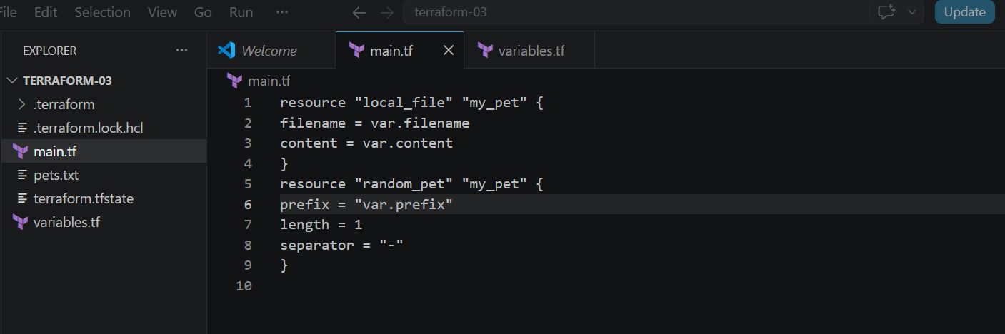
Step 4: Add variables in variables.tf
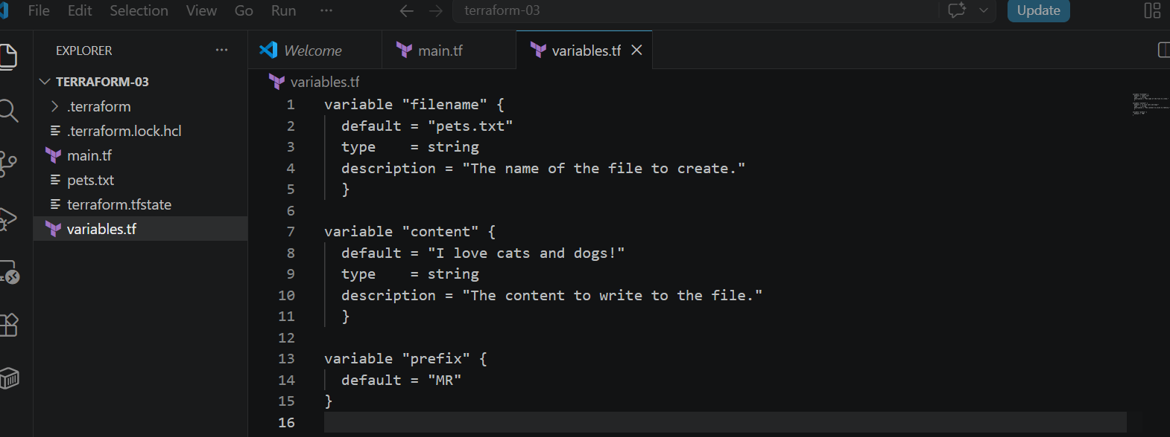

Step 5: Initialize Terraform
terraform init
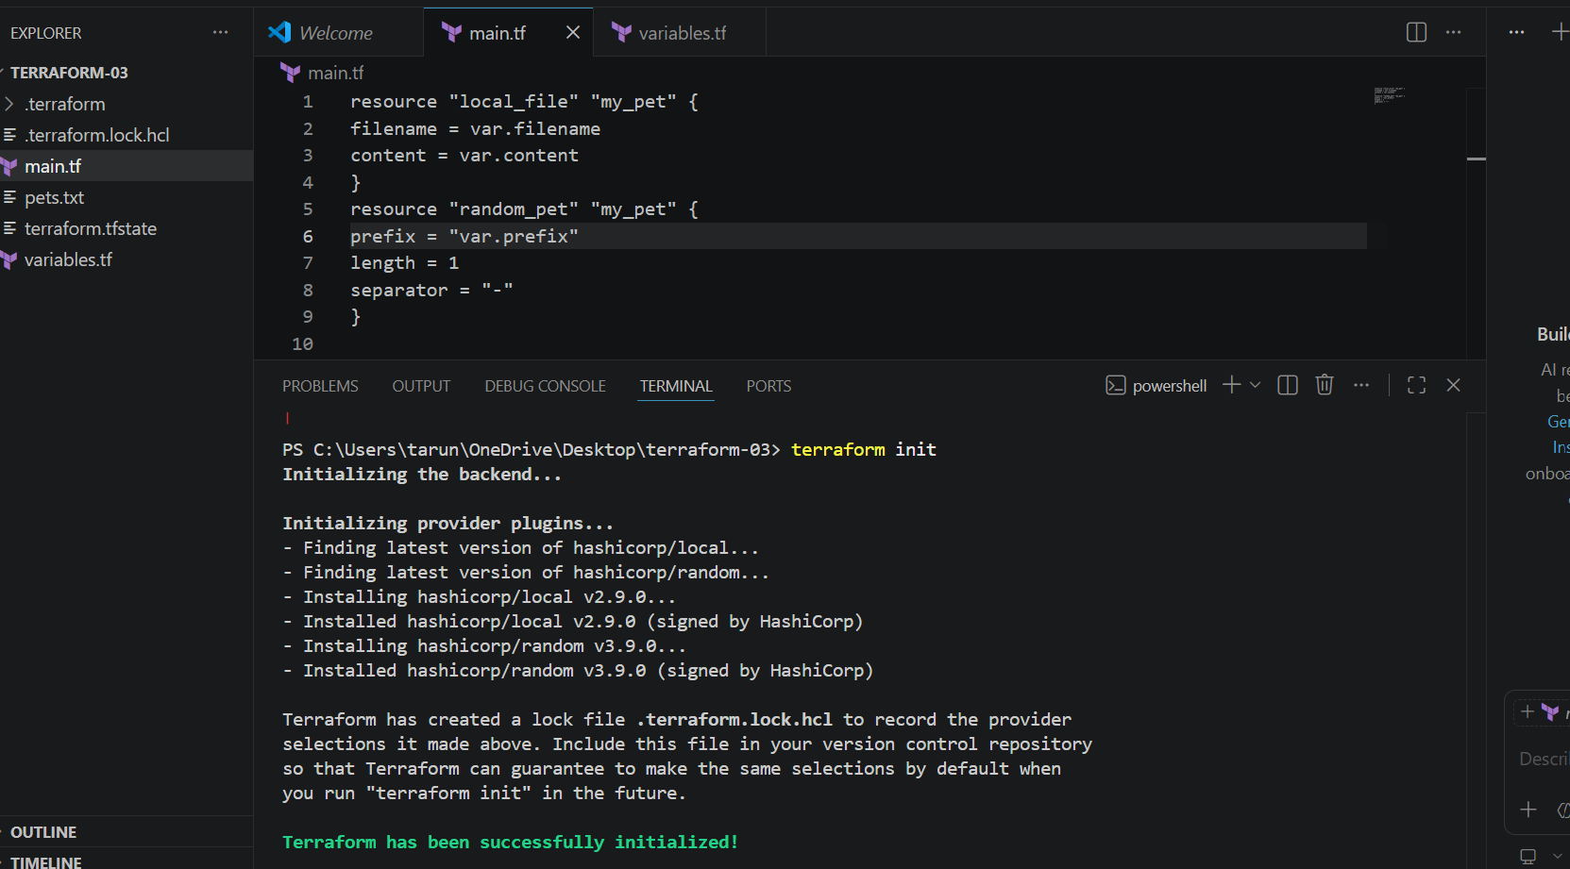
Step 6: Validate configuration
terraform validate
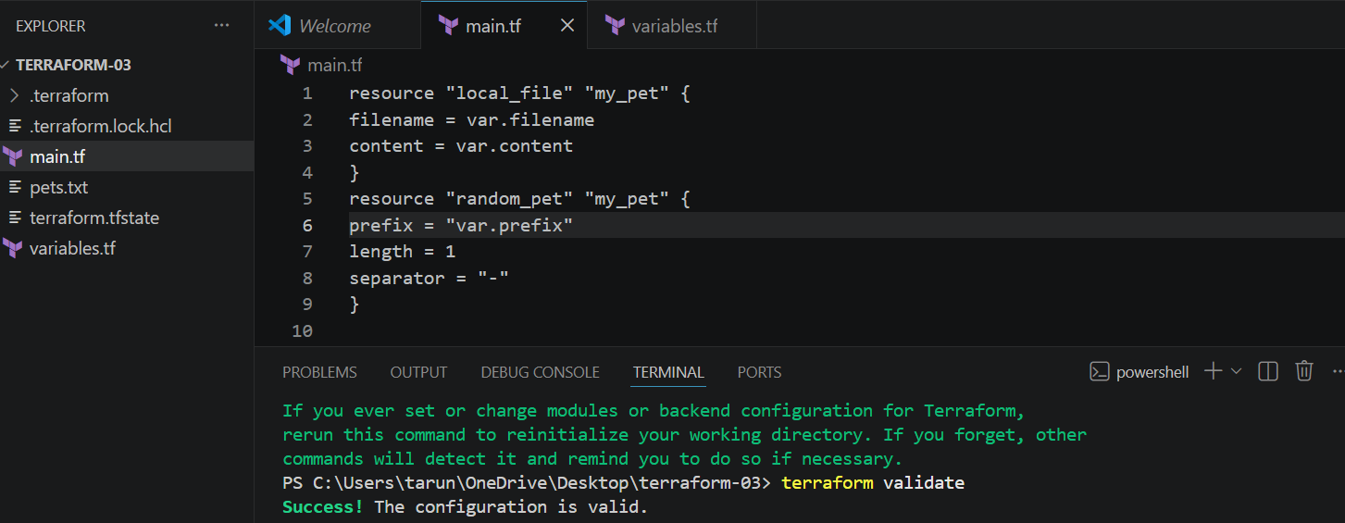

Step 7: Check execution plan
terraform plan
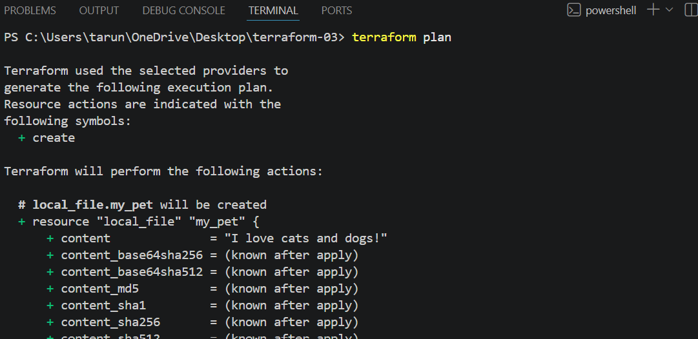
Step 8: Create resources
terraform apply
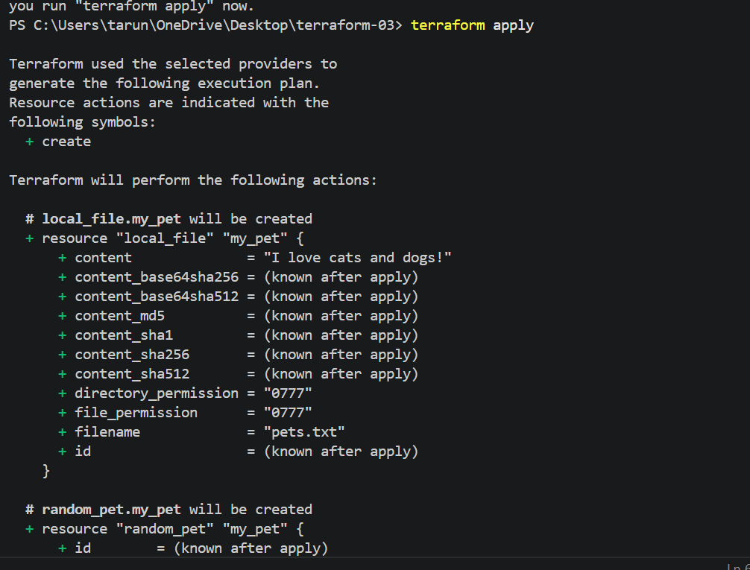

Interactive Variables — Hands-on
Step 1: Create variables.tf
variable "filename" {
}

variable "content" {
}

variable "prefix" {
}
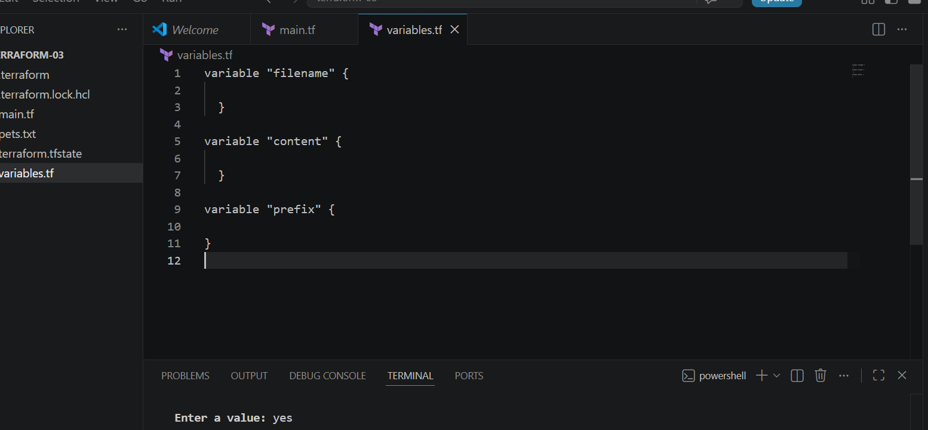
Step 2: Create main.tf
resource "local_file" "my_pet" {
filename = var.filename
content = var.content
}

resource "random_pet" "my_pet" {
prefix = var.prefix
length = 1
separator = "-"
}
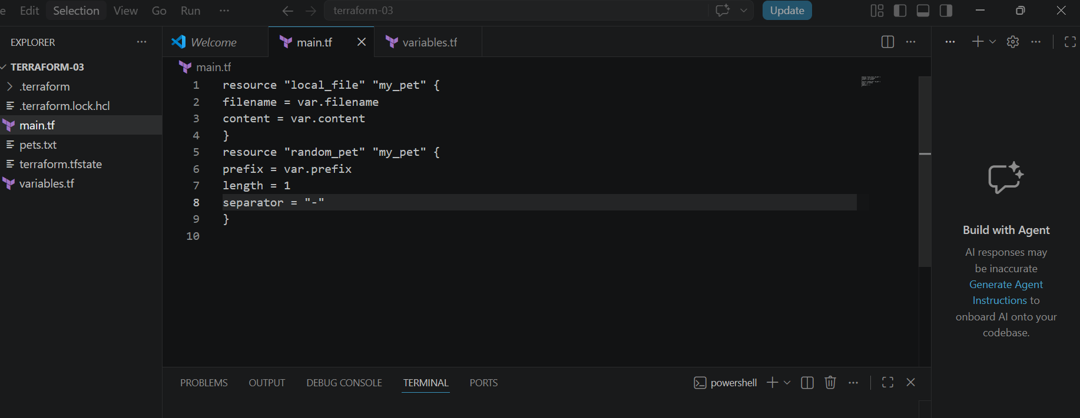
Step 3: Initialize
terraform init
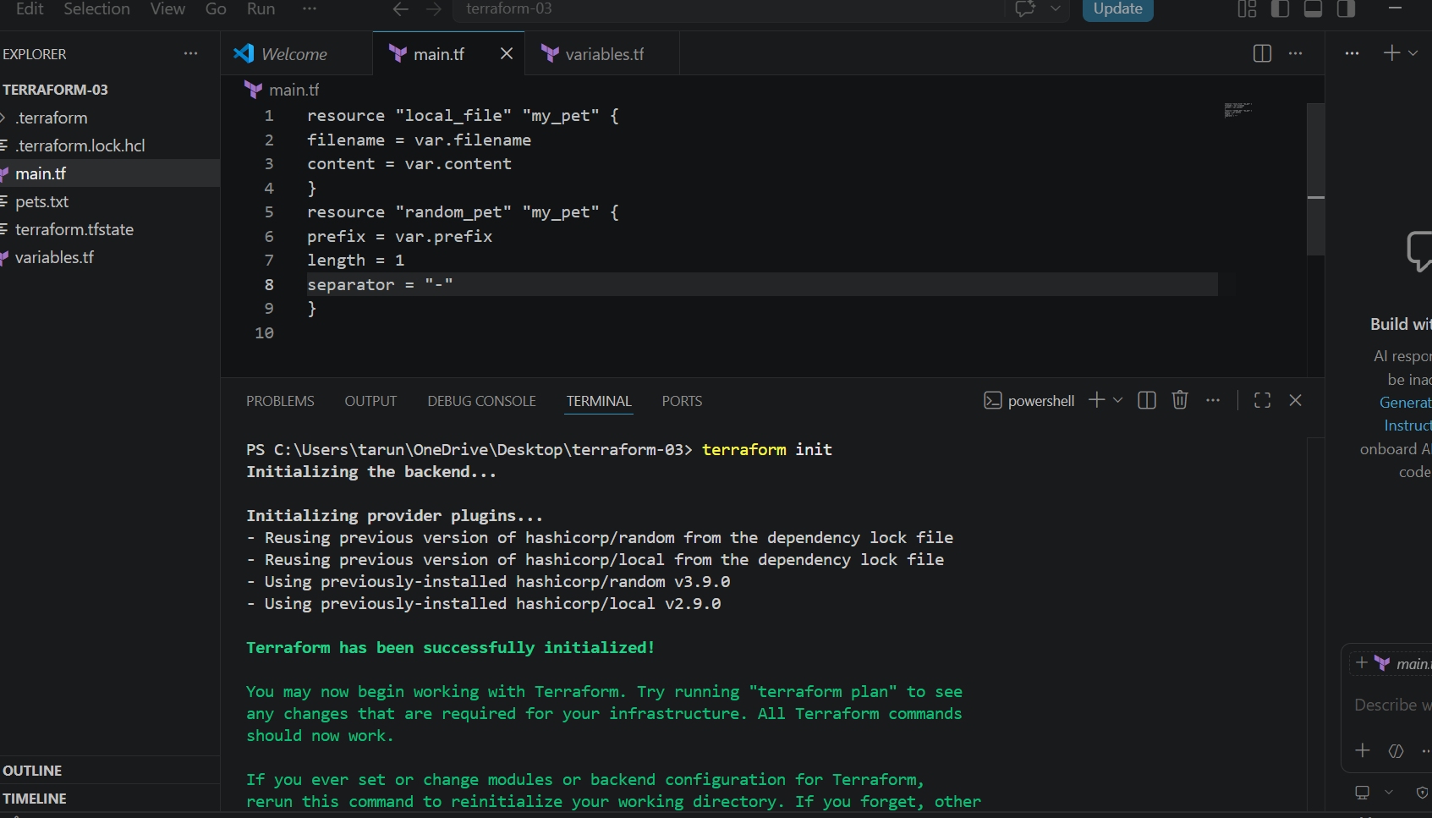
Step 4: Validate
terraform validate
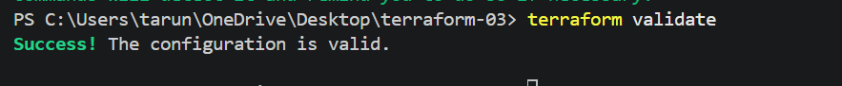
Step 5: Apply
terraform apply
Terraform will ask:
var.filename
Enter a value:

var.content
Enter a value:

var.prefix
Enter a value:
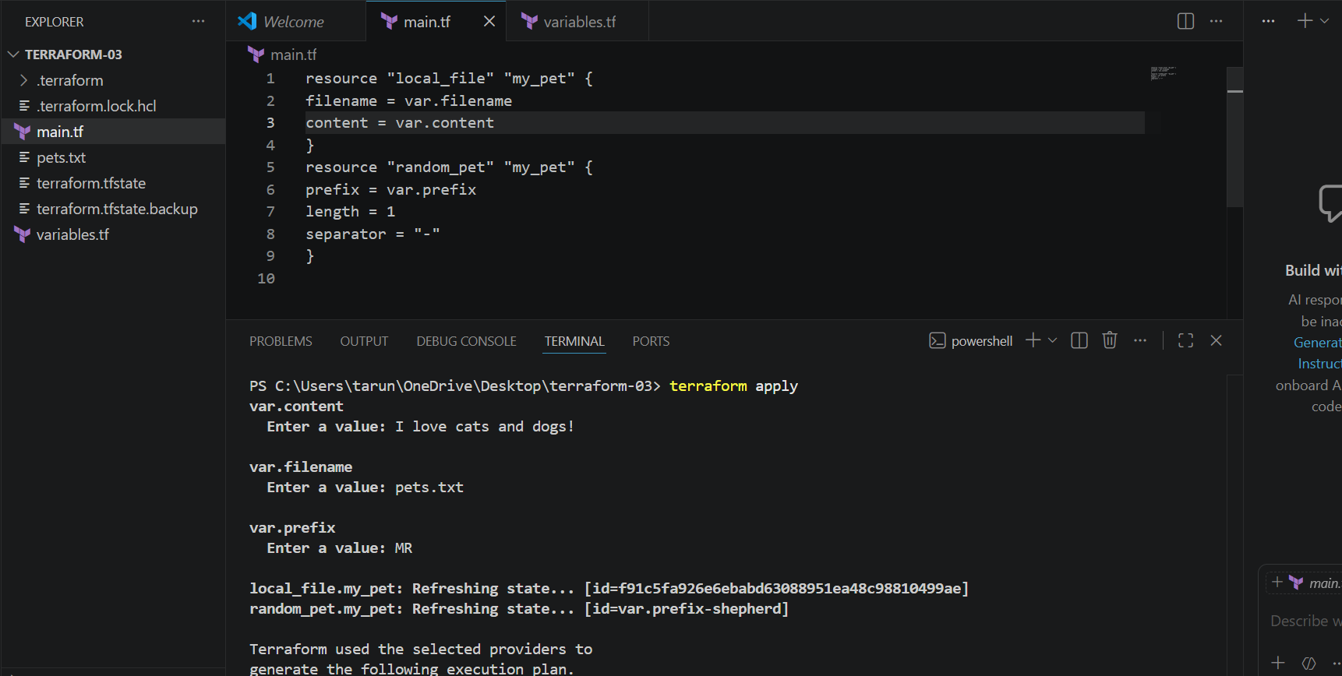
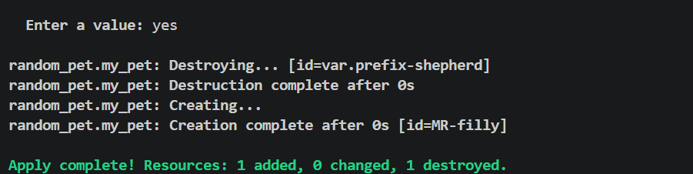
Enter your values and Terraform will create the resources.

Command-Line Flags — Terraform Variables
Step 1: variables.tf
variable "filename" {
}

variable "content" {
}

variable "prefix" {
} 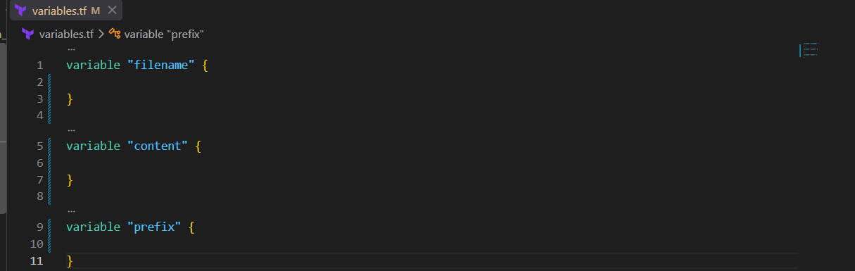
Step 2: main.tf
resource "local_file" "my_pet" {
filename = var.filename
content = var.content
}

resource "random_pet" "my_pet" {
prefix = var.prefix
length = 1
separator = "-"
} 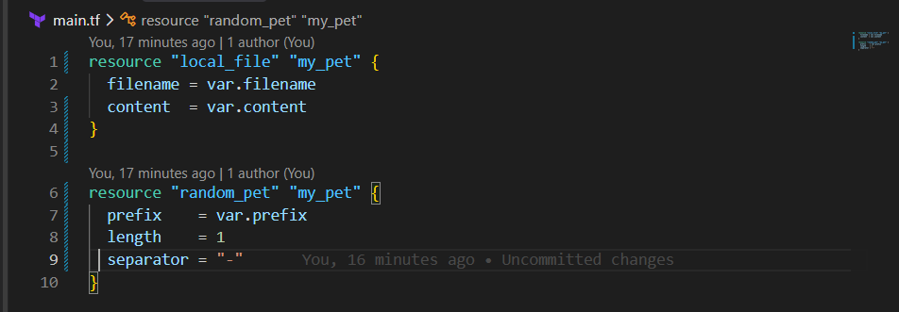
Step 3: Initialize
terraform init
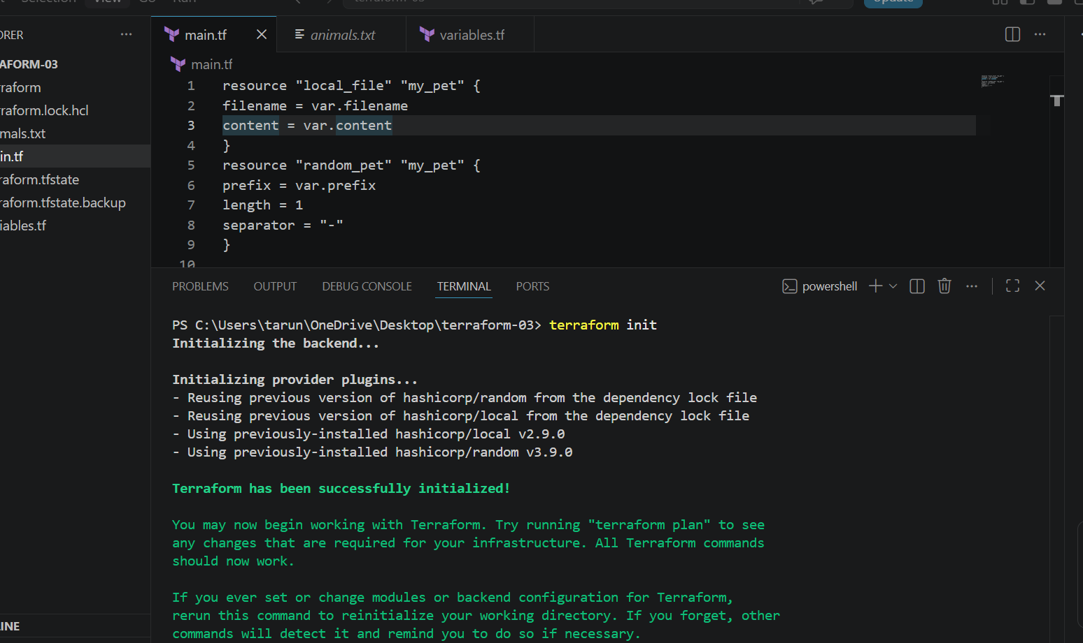
Step 4: Validate
terraform validate

Step 5: Pass values using command-line flags
terraform apply -var="filename=animals.txt" -var="content=I love elephants!" -var="prefix=DEV"
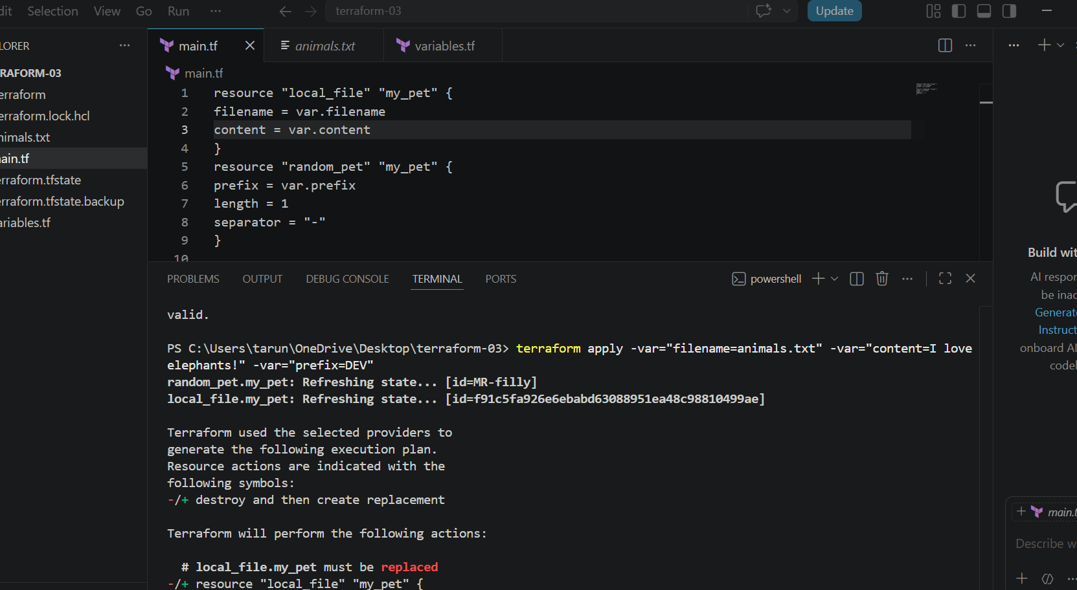
Step 6: Verify
Terraform creates:
animals.txt
with:
I love elephants!
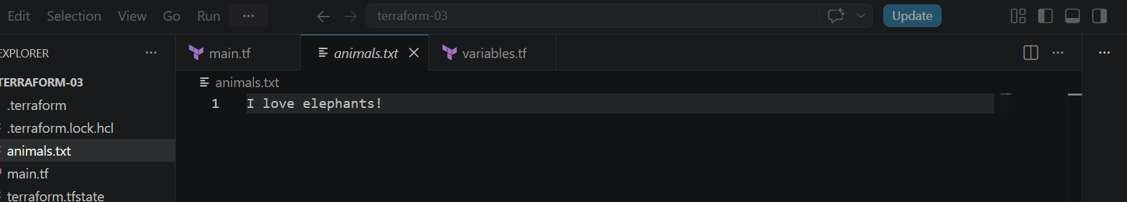

Key point: -var allows you to provide variable values directly from the command line.

Environment Variables
Your notes have a small typo: Terraform environment variables must start with TF_VAR_, not TF_val_.
Step 1: variables.tf
variable "filename" {
}

variable "content" {
}

variable "prefix" {
}
Step 2: main.tf
resource "local_file" "my_pet" {
filename = var.filename
content = var.content
}

resource "random_pet" "my_pet" {
prefix = var.prefix
length = 1
separator = "-"
}
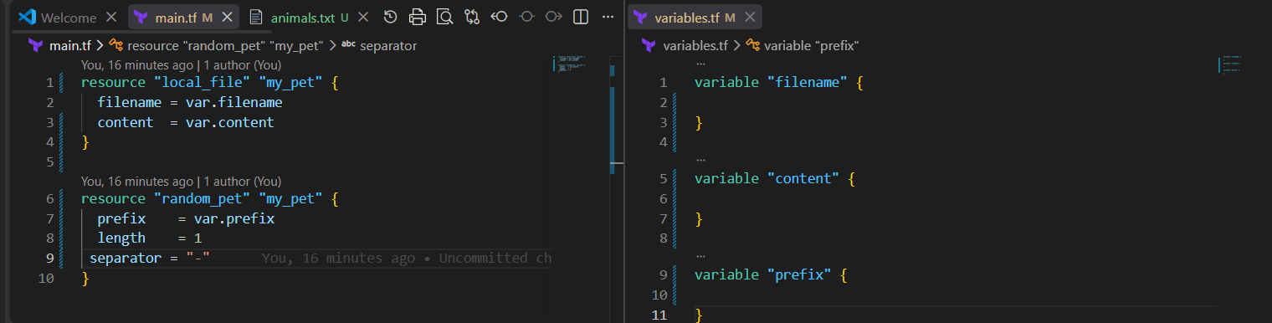
Step 3: Set variables in PowerShell
Set-Item -Path Env:TF_VAR_filename -Value "world.txt"
Set-Item -Path Env:TF_VAR_content -Value "lorpa"
Set-Item -Path Env:TF_VAR_prefix -Value "miss"
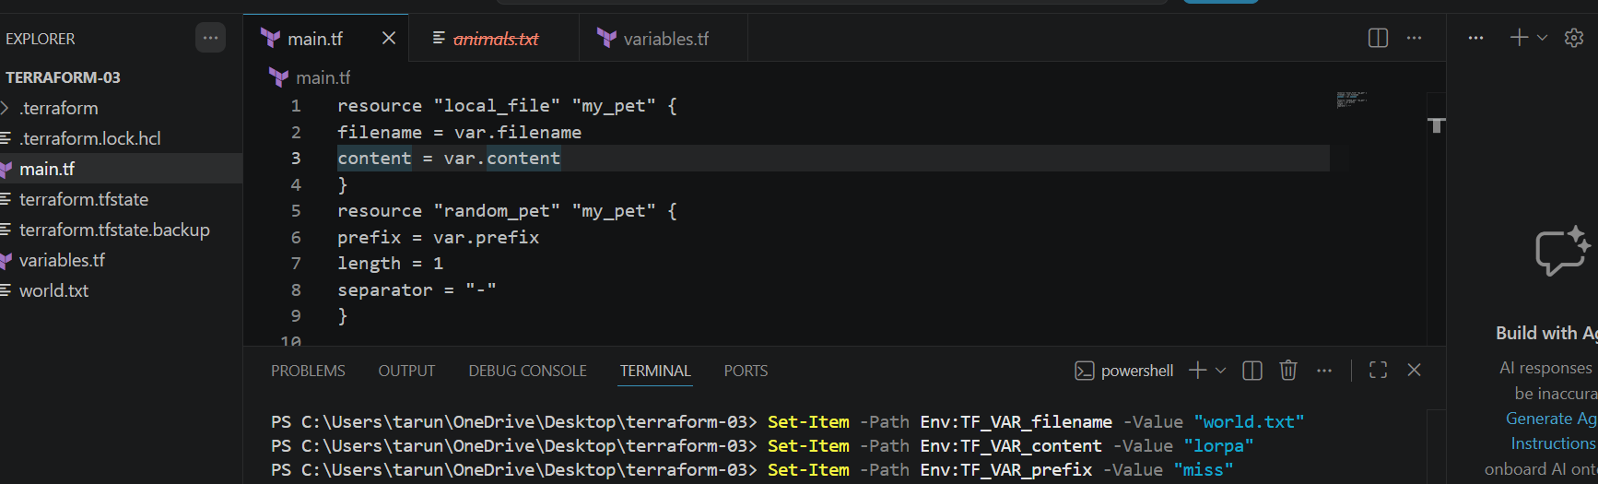
Step 4: Verify
$env:TF_VAR_filename
$env:TF_VAR_content
$env:TF_VAR_prefix
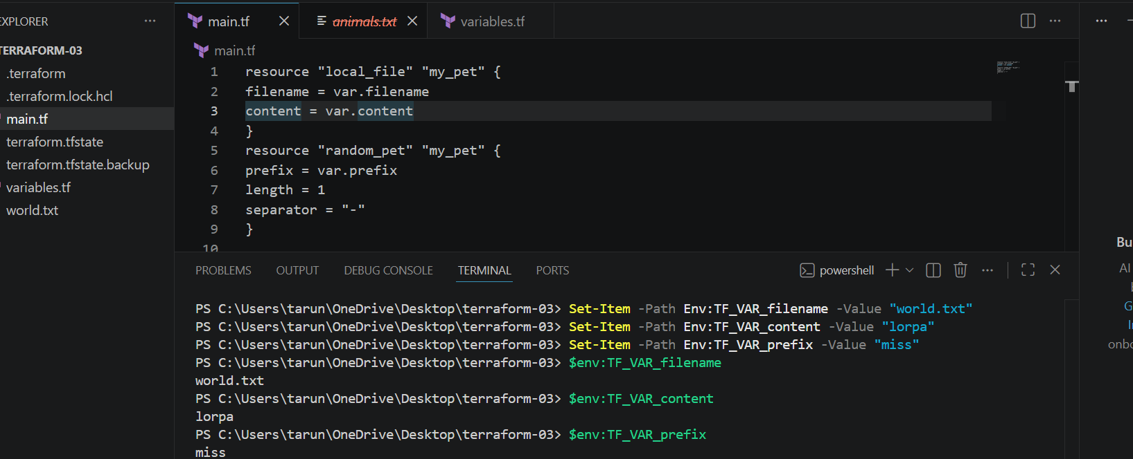
Step 5: Apply
terraform apply
Terraform automatically takes:
TF_VAR_filename → var.filename
TF_VAR_content → var.content
TF_VAR_prefix → var.prefix
To change the values
Set-Item -Path Env:TF_VAR_filename -Value "w/d.txt"
Set-Item -Path Env:TF_VAR_content -Value "lorpa"
Set-Item -Path Env:TF_VAR_prefix -Value "miss"
Then:
terraform apply
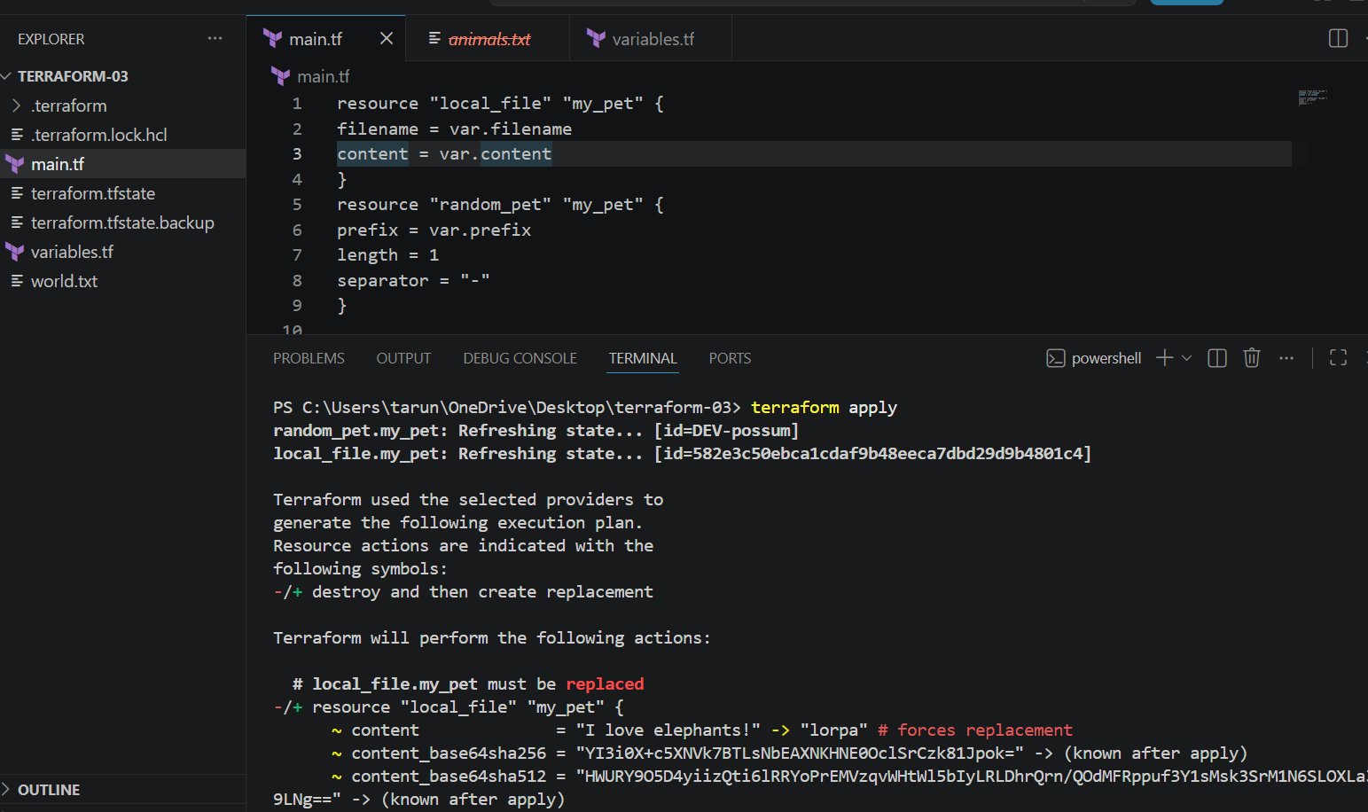

Variable Precedence
Use case: If you define a default value in variables.tf and also provide a TF_VAR_... environment variable, Terraform will use the environment variable value because it has higher precedence than the variable's default.
To prove the environment variable is overriding default
Terraform Variable Precedence
- Environment variable — TF_VAR_name
- terraform.tfvars
- *.auto.tfvars
- -var / -var-file

Step 1 — variables.tf
Create/update variables.tf:
variable "filename" {
default = "pets.txt"
}

variable "content" {
default = "I love cats"
}

variable "prefix" {
default = "DEV"
}
Here, you have defined variables + default values.

Step 2 — main.tf
resource "local_file" "my_pet" {
filename = var.filename
content = var.content
}

resource "random_pet" "my_pet" {
prefix = var.prefix
length = 1
separator = "-"
}
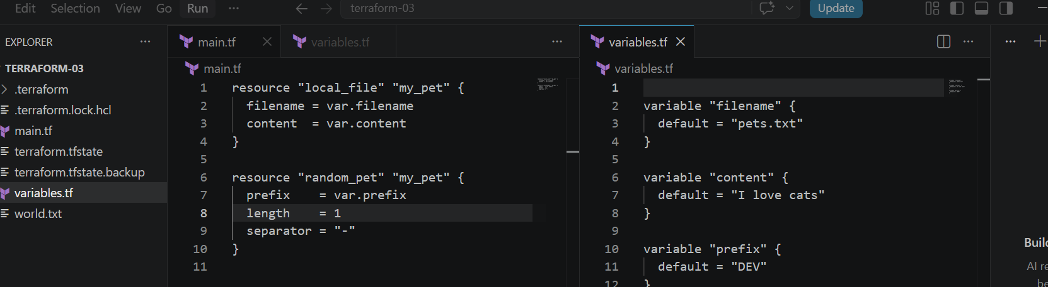

Step 3 — Open VS Code Terminal
Go to:
Terminal → New Terminal
You should see:
PS C:\Users\sriva\Desktop\Terraform-03>

Step 4 — Pass different values using Environment Variables
Set-Item -Path Env:TF_VAR_filename -Value "world.txt"
Set-Item -Path Env:TF_VAR_content -Value "lorpa"
Set-Item -Path Env:TF_VAR_prefix -Value "miss" 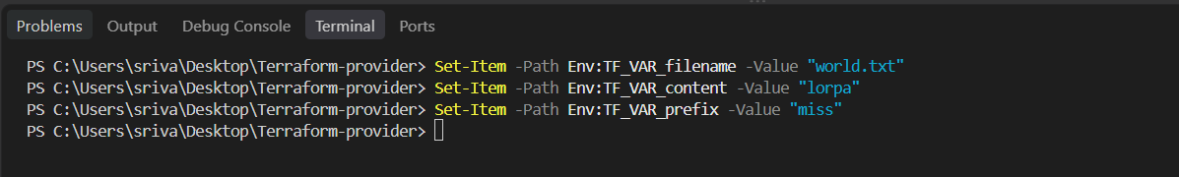 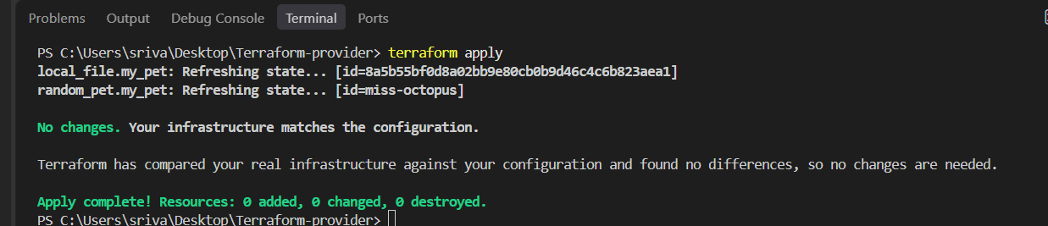

Step 5 — Verify Environment Variables
$env:TF_VAR_filename
$env:TF_VAR_content
$env:TF_VAR_prefix
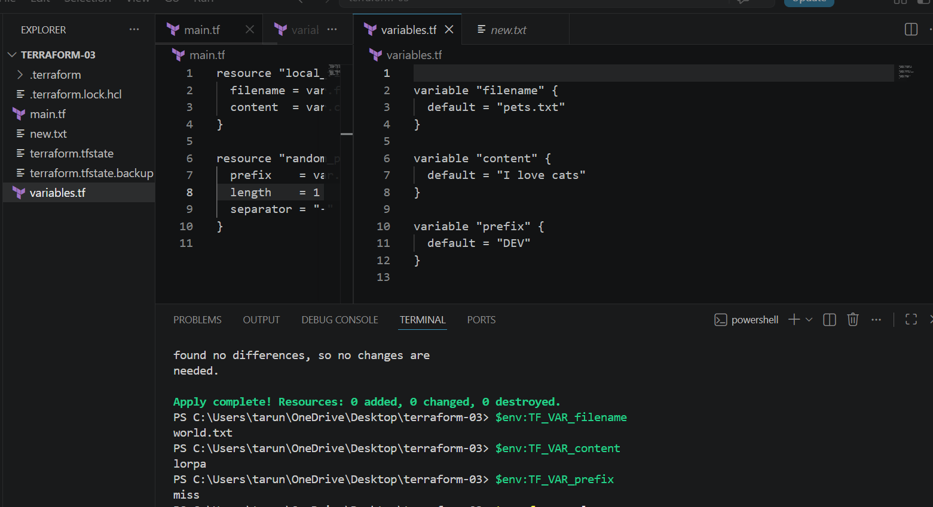

Step 6 — Run Terraform
terraform apply
Terraform will use the environment variable values, not the defaults from variables.tf.
So:
variables.tf Environment Variable
------------------------------------------------
pets.txt → world.txt
I love cats → lorpa
DEV → miss
Step 7 — Change the Environment Variable
For example:
Set-Item -Path Env:TF_VAR_filename -Value "new.txt"
Set-Item -Path Env:TF_VAR_content -Value "Hello Terraform"
Set-Item -Path Env:TF_VAR_prefix -Value "MR"
Then:
terraform apply
Terraform will detect the changes and update the resources.
Key point: default in variables.tf is the fallback value. TF_VAR_* environment variables override the default.
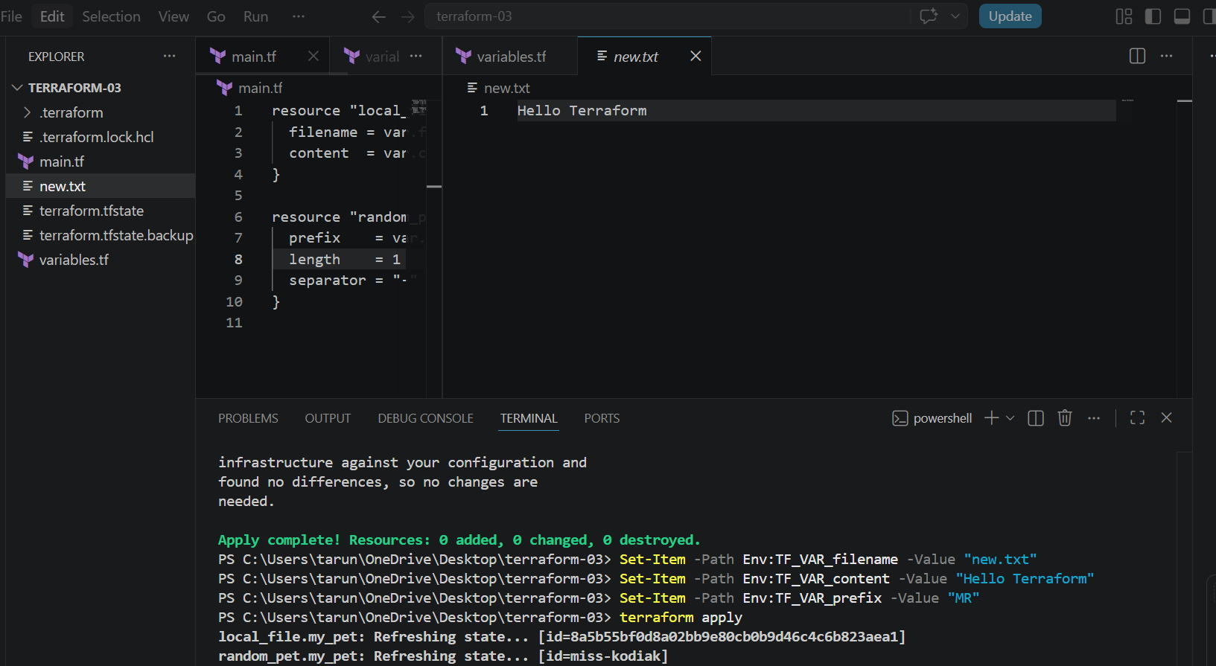
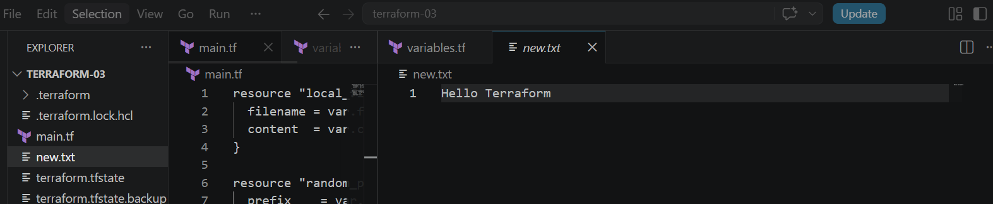

Terraform Resource Dependency
Step 1: Open your Terraform folder in VS Code
Open your existing folder:
C:\Users\sriva\Desktop\Terraform-provider

Step 2: Create main.tf
Use this:
resource "random_pet" "my_pet" {
prefix = "DEV"
length = 1
}

resource "local_file" "my_file" {
filename = "pet.txt"
content = random_pet.my_pet.id
}
Here:
random_pet.my_pet.id
is the resource reference.
It means: Get the id value from random_pet.my_pet and put it inside pet.txt.
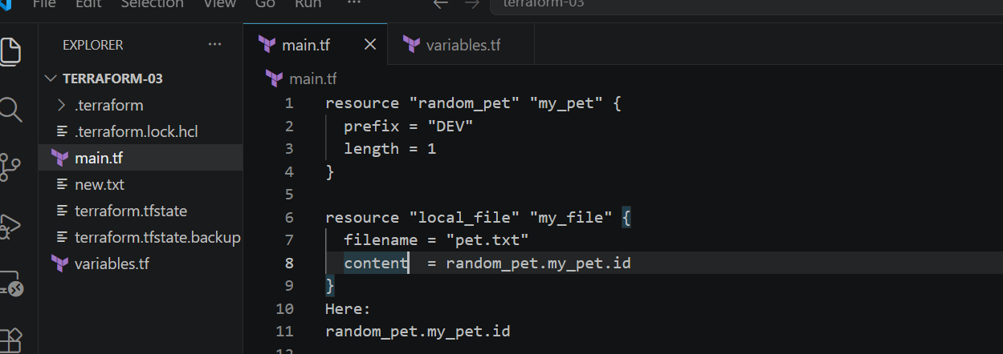

Step 3: Initialize Terraform
In VS Code terminal:
terraform init

Step 4: Check the plan
terraform plan
Terraform understands that:
random_pet → local_file
because local_file references random_pet.

Step 5: Apply
terraform apply
yes 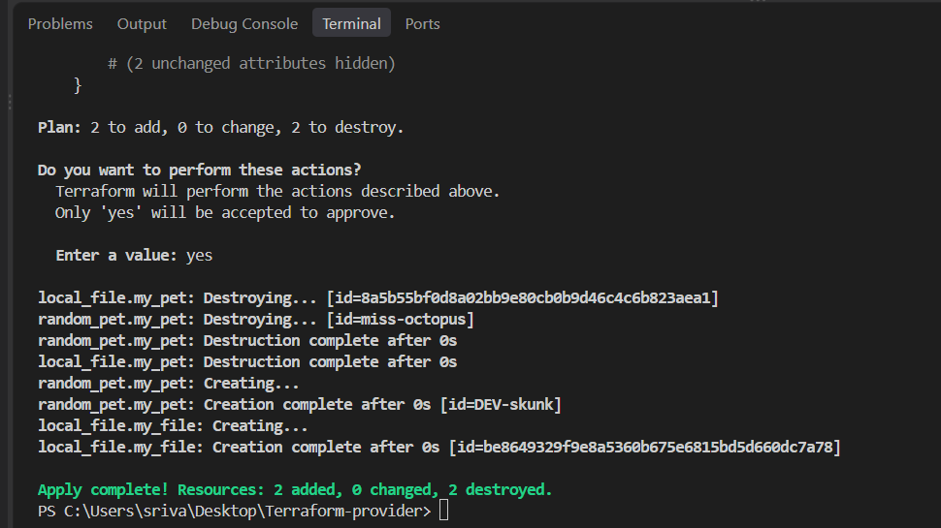

Step 6: Check the generated file
You will see:
pet.txt
DEV-skunk
The value comes from:
random_pet.my_pet.id
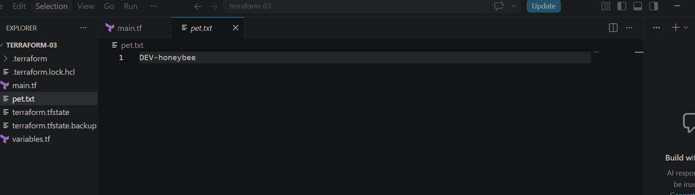

Step 7: Understand the dependency
Terraform creates:
random_pet.my_pet
↓
↓ reference
↓
local_file.my_file
So Terraform automatically knows:
Create random_pet first, then create local_file.
This is called an implicit dependency.

Step 8: Try Explicit Dependency
Change main.tf to: 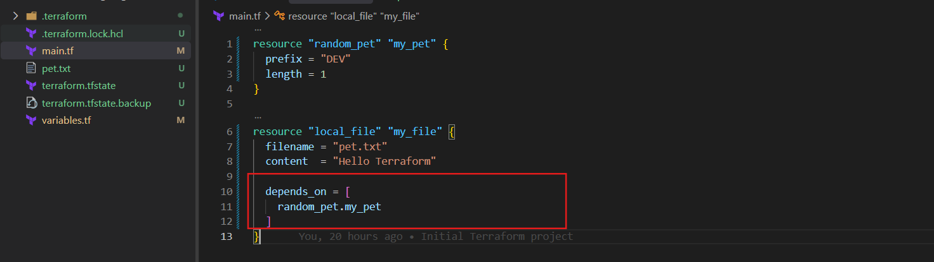
Now there is no resource reference in content.
But:
depends_on = [random_pet.my_pet]
manually tells Terraform:
Create random_pet.my_pet before local_file.my_file.

Step 9: Apply again
terraform plan
terraform apply
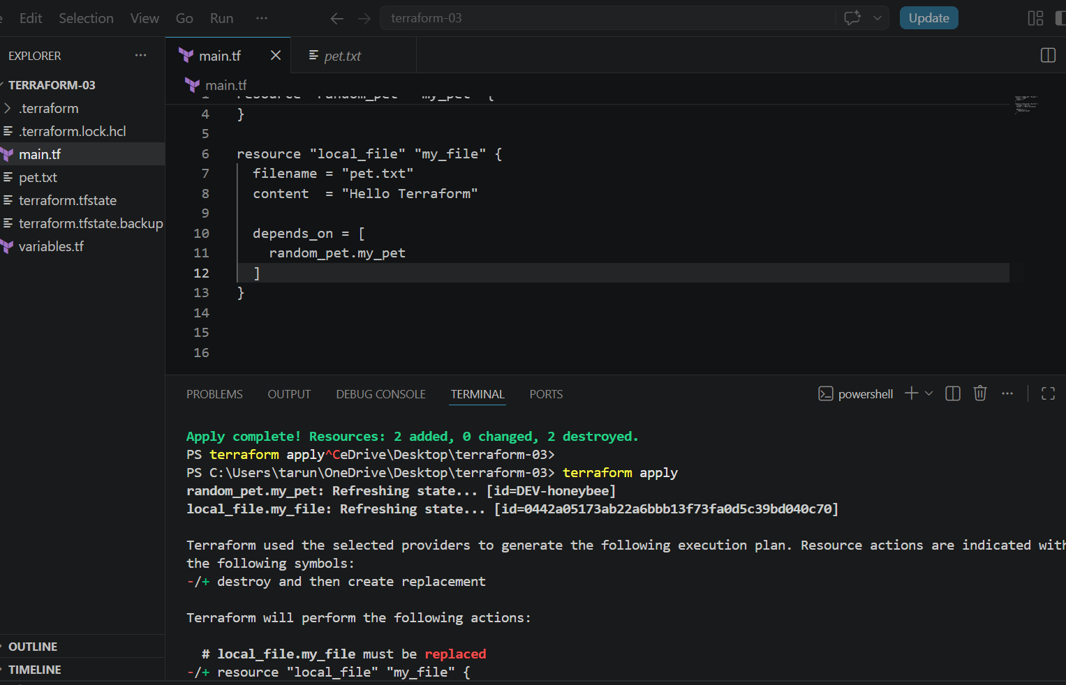
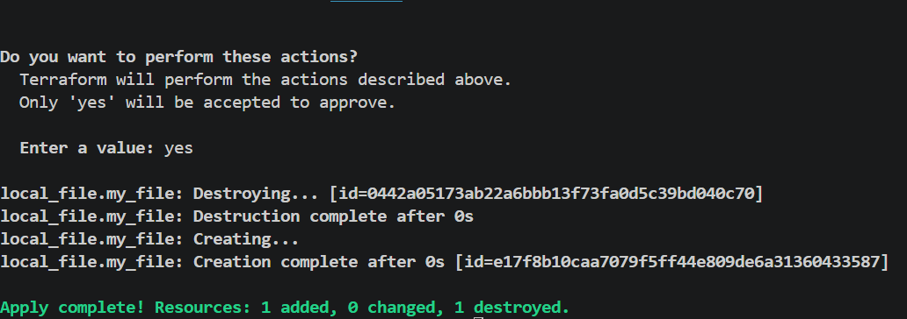

Terraform Output Variables
An output variable is used to display or expose a value after Terraform creates a resource.
For example, after creating a random pet, we can display its name.

Step 1: Keep your main.tf
resource "random_pet" "my_pet" {
prefix = "DEV"
length = 1
}
Step 2: Create outputs.tf
output "pet_name" {
value = random_pet.my_pet.id
}
Here:
random_pet.my_pet.id
is the resource reference.
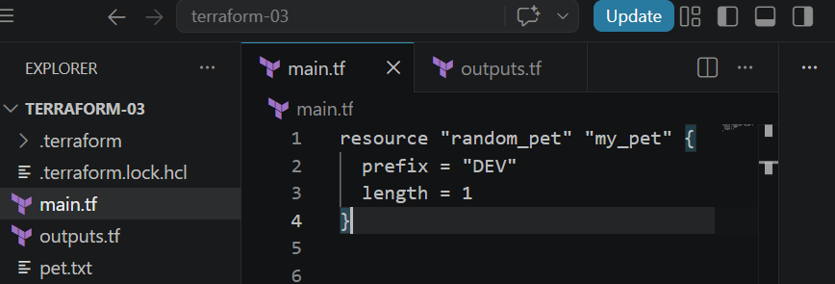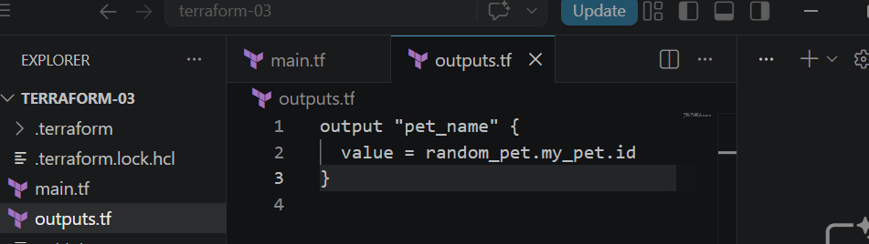

Step 3: Run Terraform
terraform init 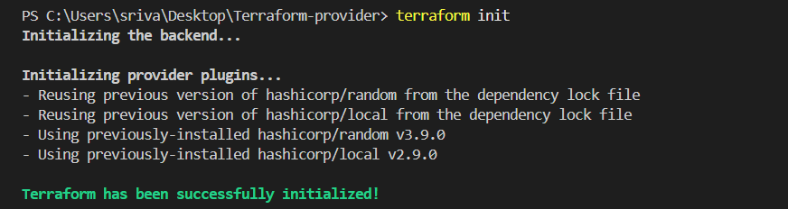
terraform apply
Enter:
yes 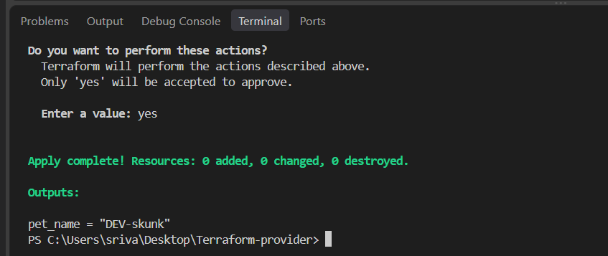

Step 4: Check the output
You should see something like:
Outputs:
pet_name = "DEV-Skunk"

Step 5: Display output anytime
After terraform apply, run:
terraform output
Or only the specific output:
terraform output pet_name
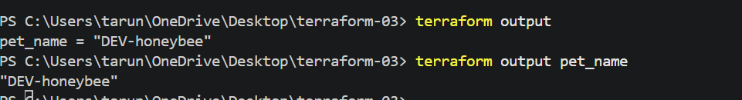

Simple interview definition
Output variable is used to display or expose values generated by Terraform resources.
Flow:
Resource
↓
random_pet.my_pet.id
↓
output "pet_name"
↓
terraform output
Important: output is different from an input variable.
- variable → gives values to Terraform
- output → gives values from Terraform

2. Integrate Terraform in Jenkins using the Terraform plugin..

- Jenkins → Manage Jenkins → Plugins
  - Search Terraform
  - Install Terraform Plugin.
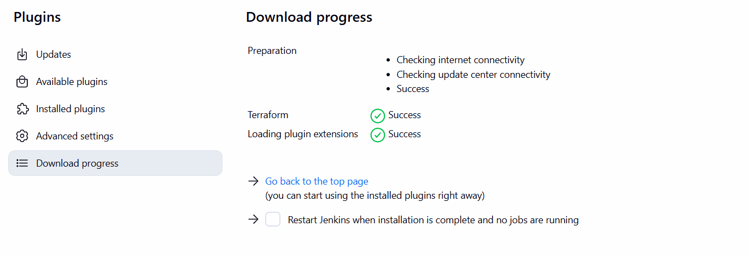
- Manage Jenkins → Tools
  - Find Terraform installations
  - Click Add Terraform
  - Name: terraform
  - Select Terraform version / auto-install
  - Save
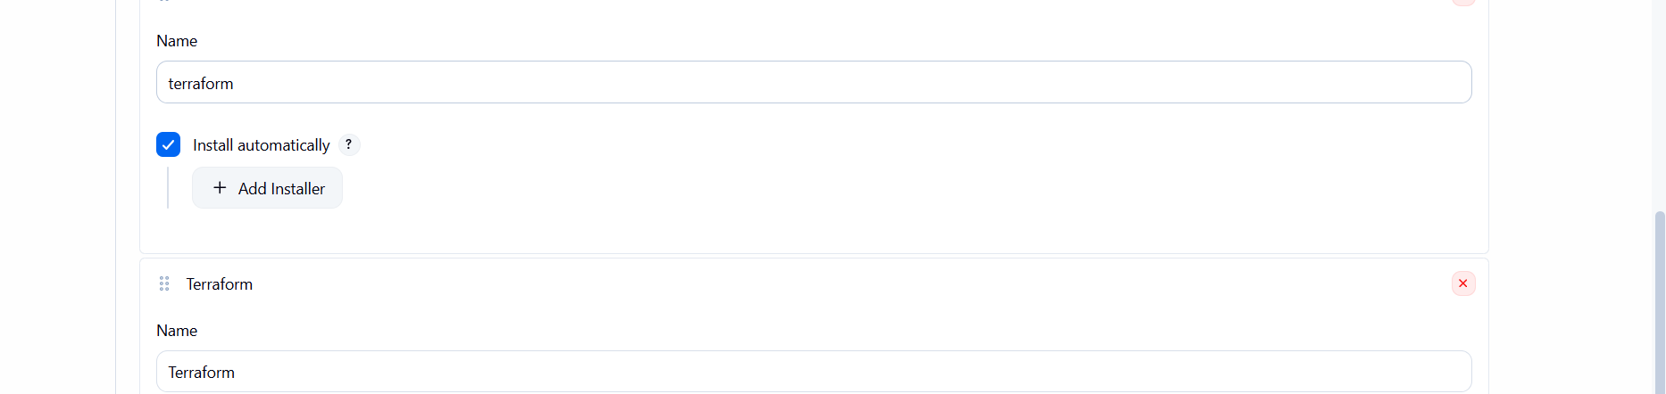
- Create Jenkins Pipeline
  - New Item → Terraform-jenkins pipeline
  - Select Pipeline
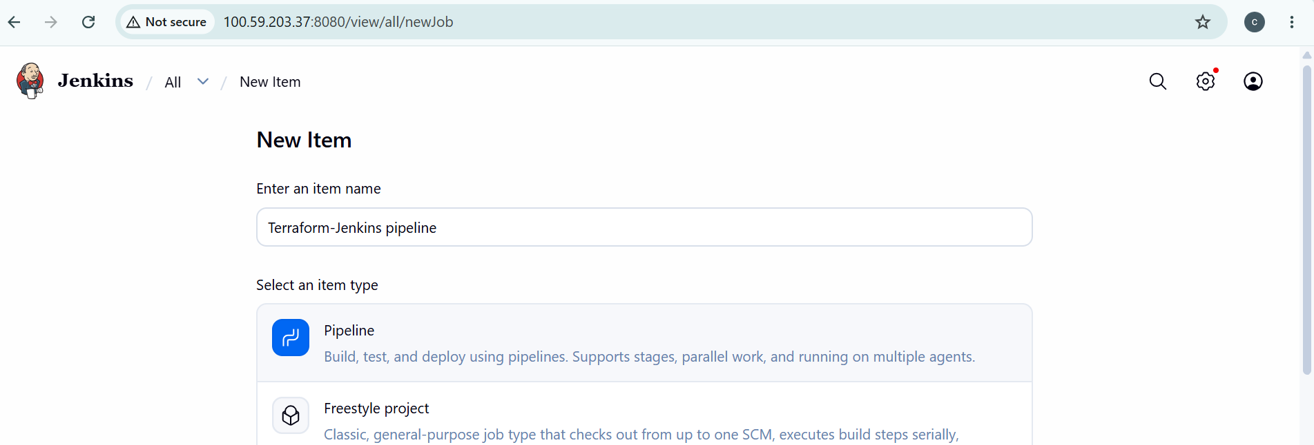
- Add this Jenkinsfile:
pipeline {
agent any

environment {
TF_HOME = tool name: 'terraform',
type: 'org.jenkinsci.plugins.terraform.TerraformInstallation'
PATH = "${TF_HOME}:${env.PATH}"
}

stages {
stage('Checkout') {
steps {
checkout scm
}
}

stage('Terraform Init') {
steps {
sh 'terraform init'
}
}

stage('Terraform Validate') {
steps {
sh 'terraform validate'
}
}

stage('Terraform Plan') {
steps {
sh 'terraform plan'
}
}
}
}
- Connect GitHub
  - Pipeline → Pipeline script from SCM
  - SCM: Git
  - Add your GitHub repository
  - Branch: main
  - Script Path: Jenkinsfile
- Build Now → check Console Output.

Flow
GitHub → Jenkins → Terraform Plugin → Terraform → AWS
Jenkins Terraform Plugin and Terraform AWS Provider are different things. terraform init downloads the AWS provider automatically.
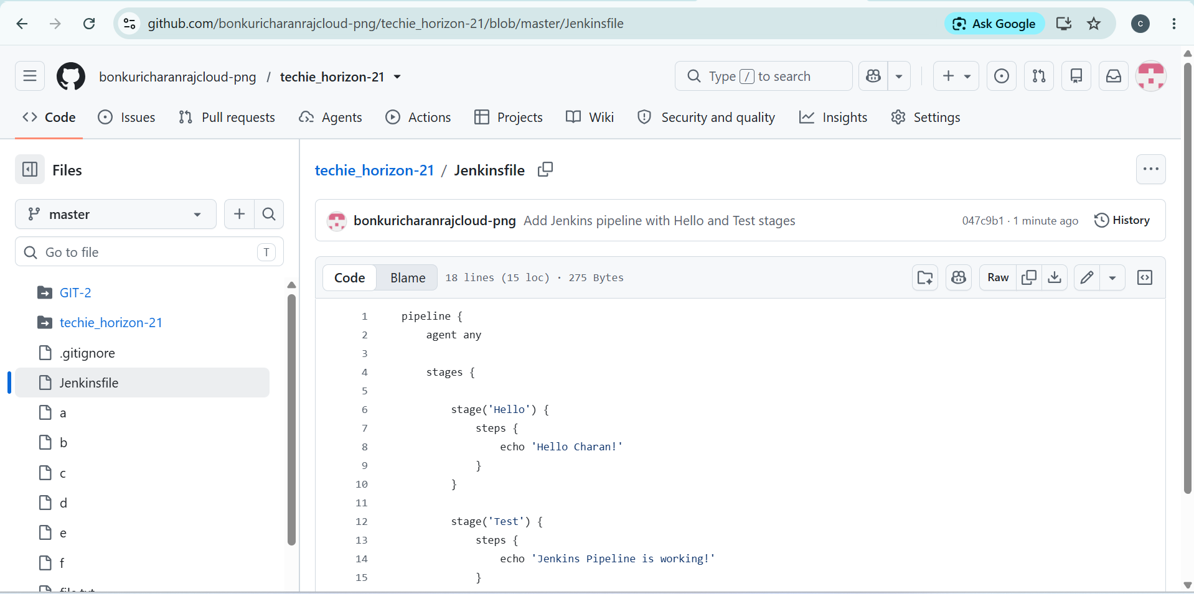
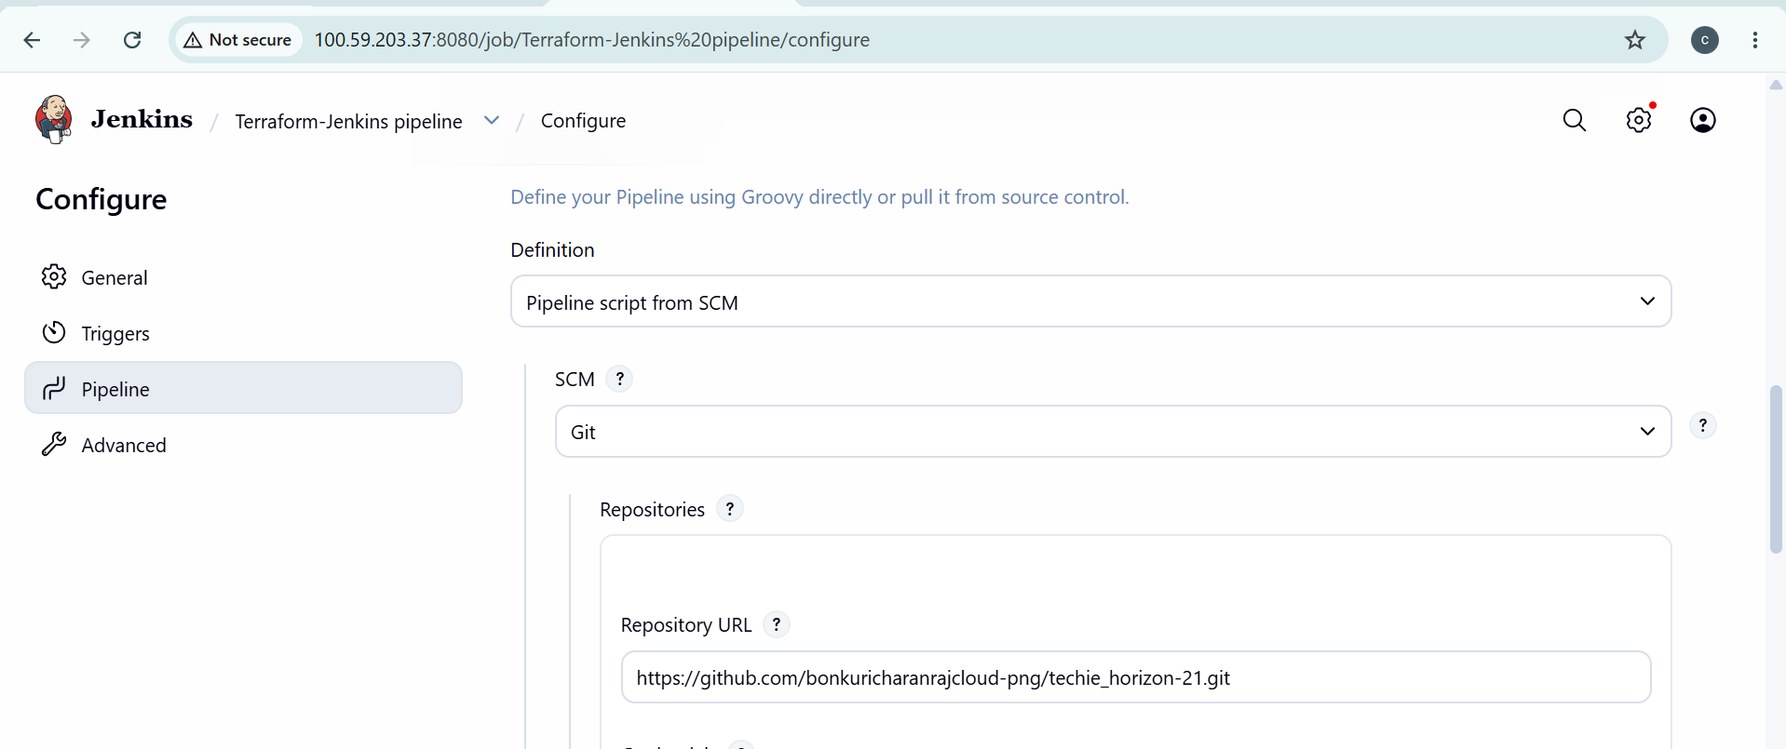

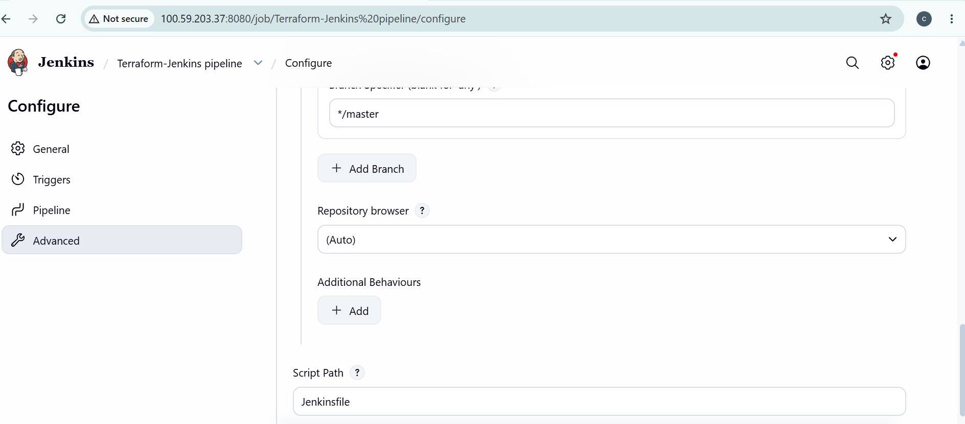
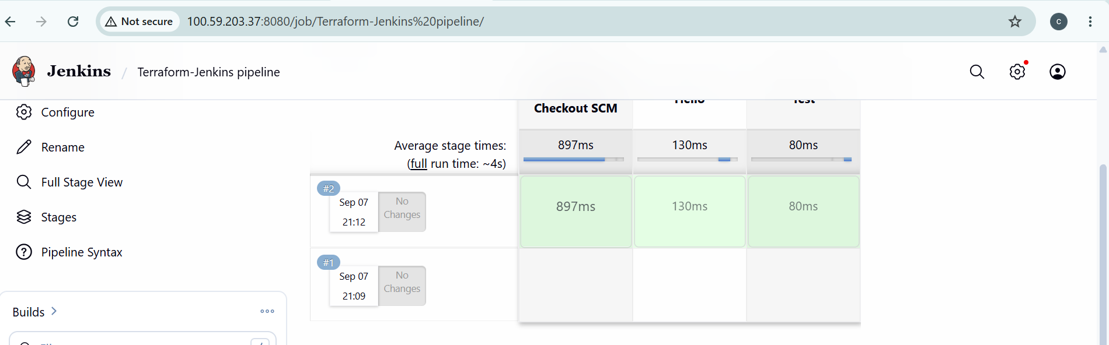

3. Create one Jenkins job using Maven Project for the code below with two stages:.
◦ Stage 1:Git clone.
◦ Stage 2:Maven CompilationCode:https://github.com/betawins/java-Working-app.git.

1. Create Jenkins Job
Jenkins → New Item
Name:
java-working-app
Select:
Maven project
Click OK. Jenkins supports a dedicated Maven project type.
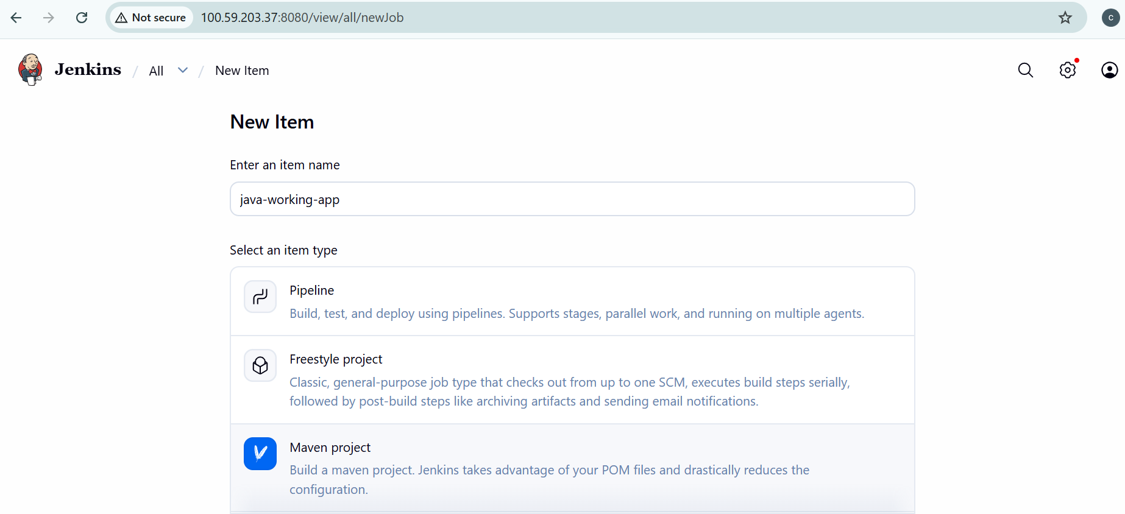
2. Stage 1 — Git Clone
In Source Code Management:
Select:
Git
Repository URL:
https://github.com/betawins/java-Working-app.git
Branch:
*/main
If the repository is public, you don't need credentials.
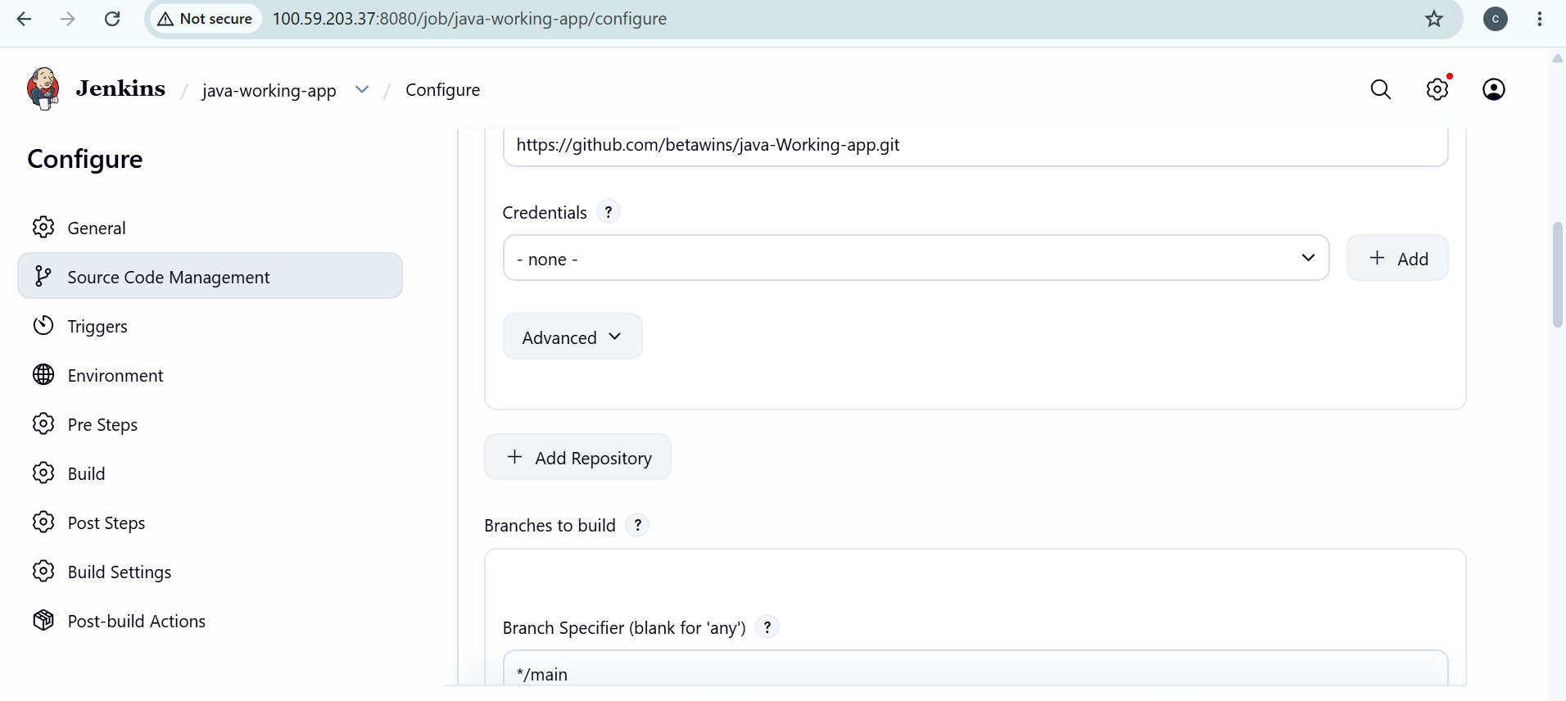
3. Stage 2 — Maven Compilation
Find Build section.
In Goals and options, enter:
clean compile
That's it. Maven will compile the Java project using its pom.xml.
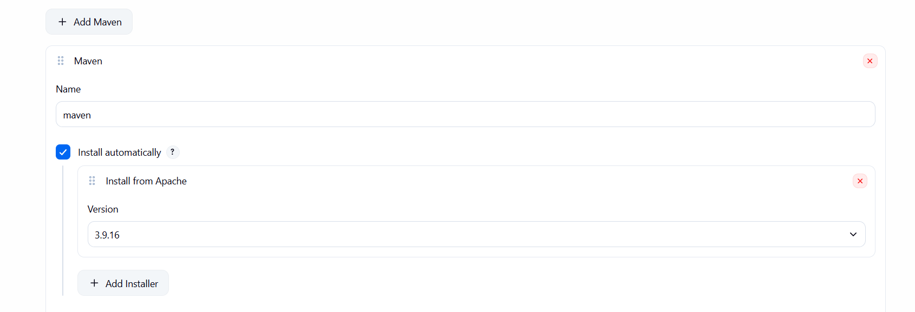
4. Save and Build
Click:
Save → Build Now
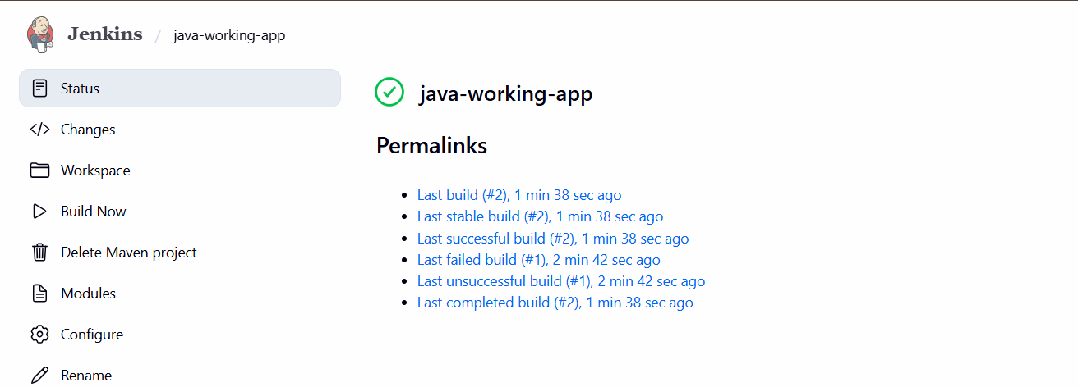
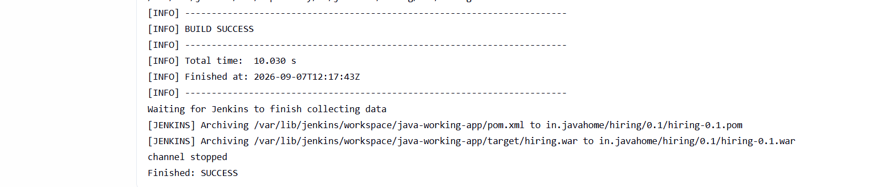
Then:
Build #1 → Console Output
You should see:
Git clone
↓
Downloading Maven dependencies
↓
mvn clean compile
↓
BUILD SUCCESS
So your two stages are effectively:
Stage 1: Git Clone
↓
Stage 2: Maven Compilation
↓
SUCCESS
For this particular requirement, you do not need a Jenkinsfile because you're specifically creating a Maven Project job.
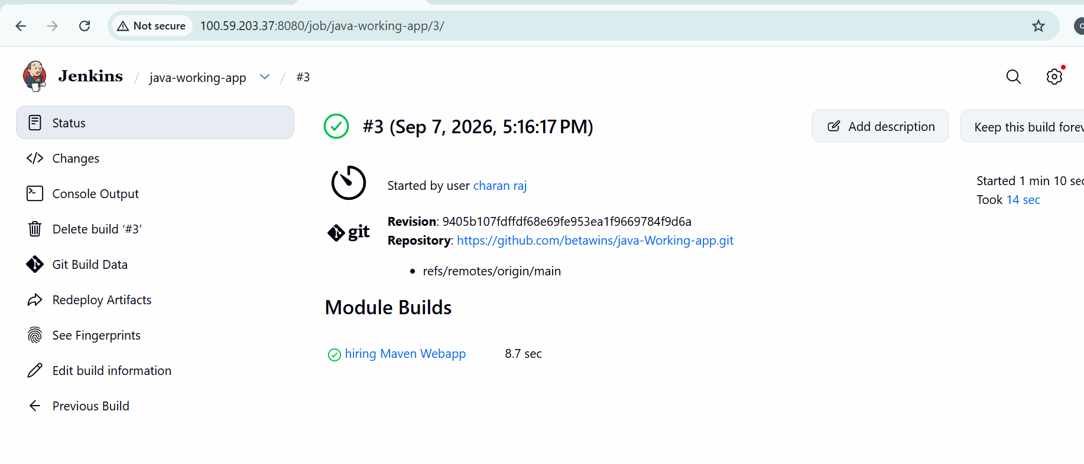
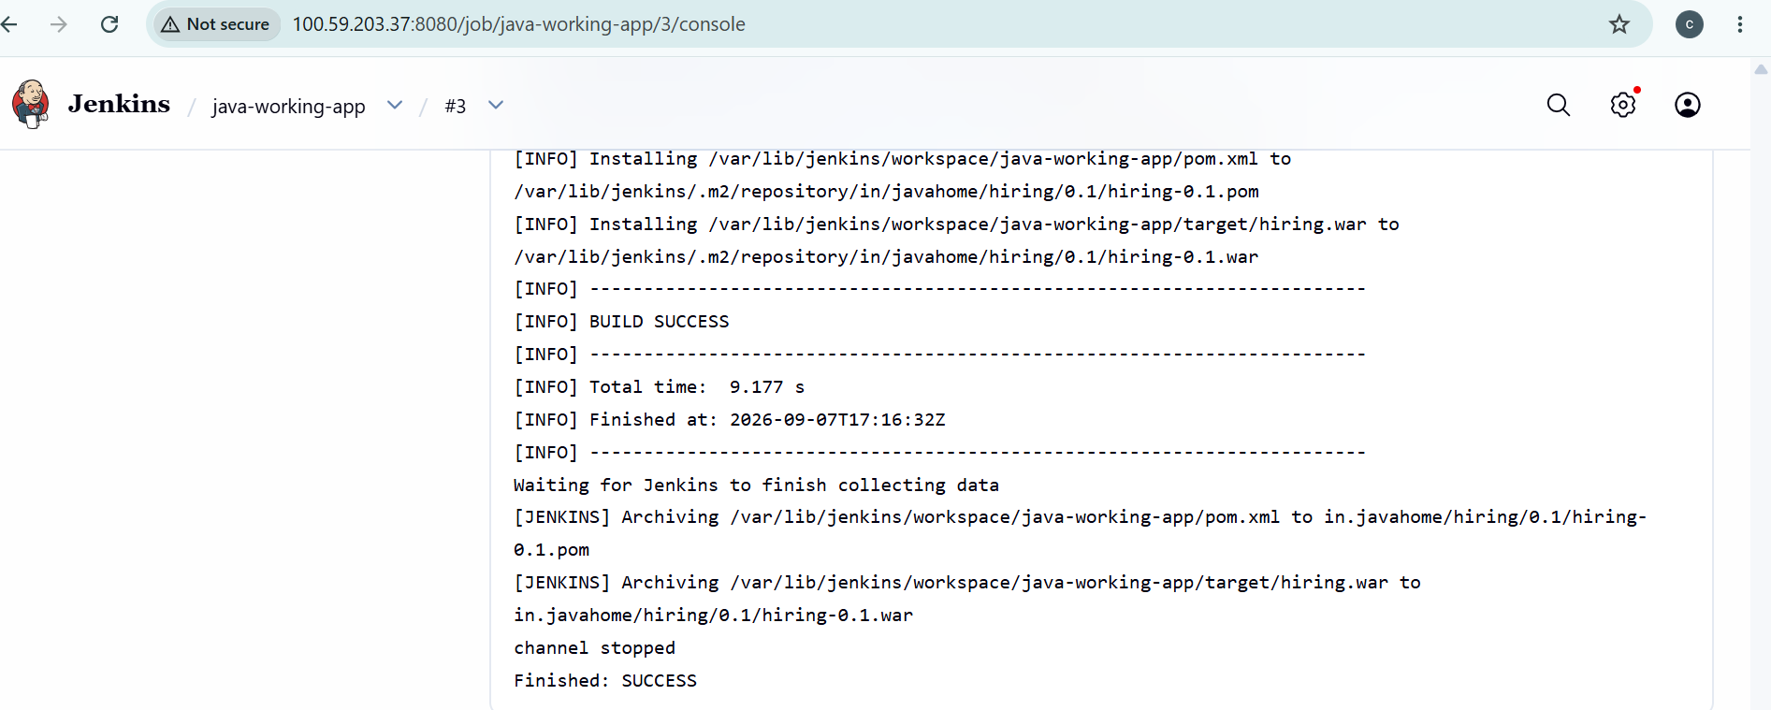

4. Use the same code and create a parameterized job in Jenkins with:.
◦ Stage 1:Git clone.
◦ Stage 2:Maven CompilationCode:https://github.com/betawins/java-Working-app.git.

Jenkins job will have:
- Stage 1 — Git Clone
- Stage 2 — Maven Compilation
Git repository:
https://github.com/betawins/java-Working-app.git

Step 1: Create Jenkins Job
Go to Jenkins:
Dashboard → New Item
Enter:
java-working-app
Select:
Pipeline
Click OK.
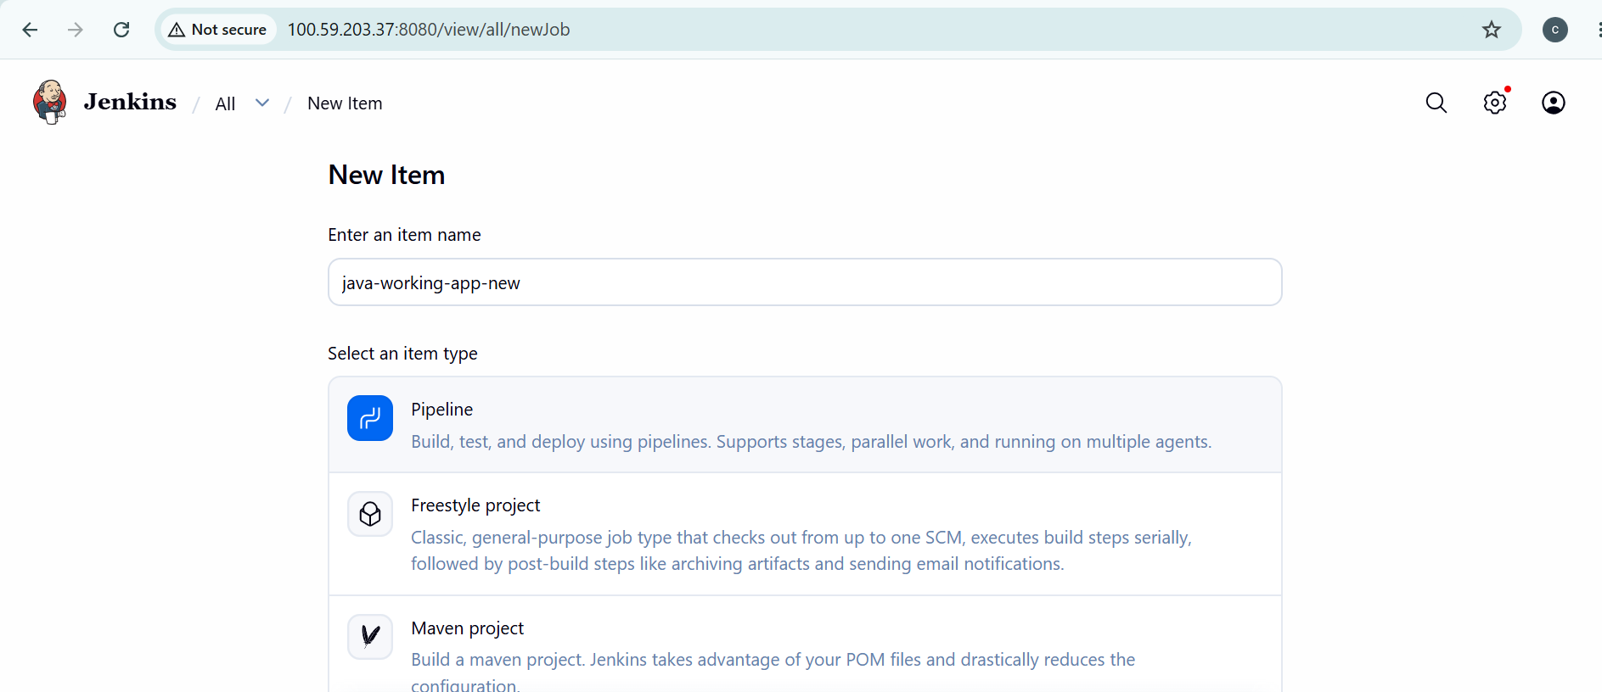

Step 2: Make it Parameterized
In the job:
Configure → General
Check:
☑ This project is parameterized
Click:
Add Parameter → Choice Parameter
Use:
Name: BRANCH
Choices:
Main
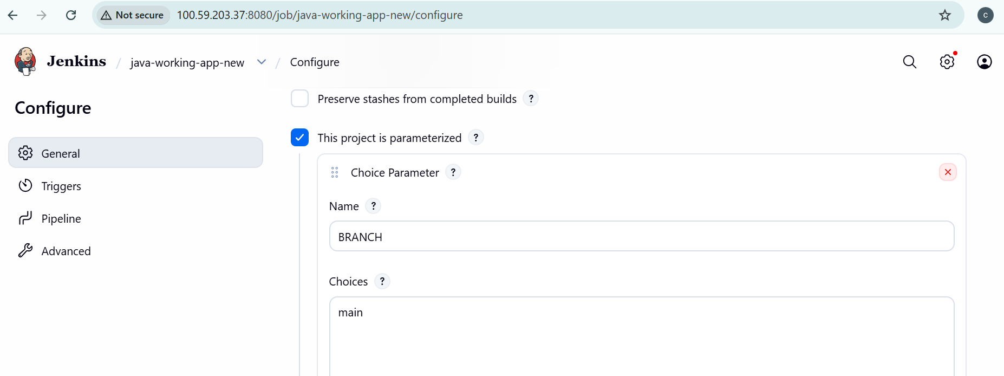

Step 3: Add Pipeline
Go to:
Pipeline → Definition
Select:
Pipeline script
Paste this:
pipeline {
agent any

parameters {
choice(
name: 'BRANCH',
choices: ['main', 'master'],
description: 'Select Git branch'
)
}

stages {

stage('Git Clone') {
steps {
git branch: "${params.BRANCH}",
url: 'https://github.com/betawins/java-Working-app.git'
}
}

stage('Maven Compilation') {
steps {
sh 'mvn clean compile'
}
}
}
}
Click:
Save
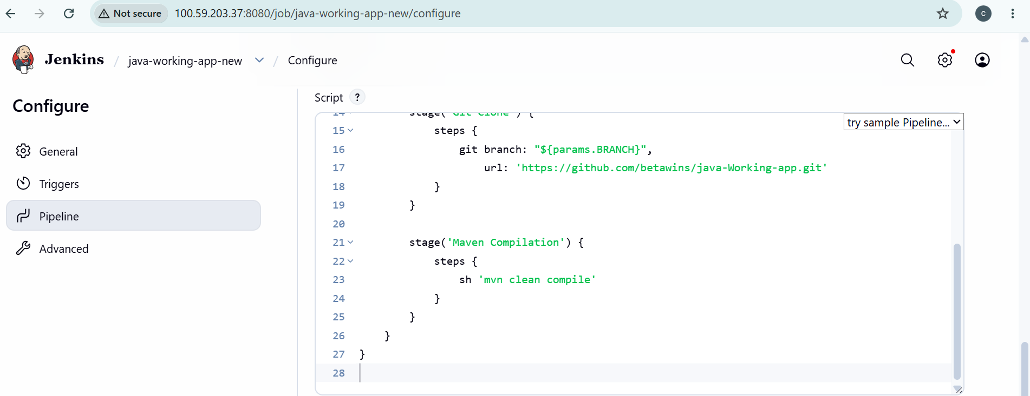

Step 4: Run the Job
Click:
Build with Parameters

You will see:
BRANCH
[main ▼]
Select:
main
Click:
Build
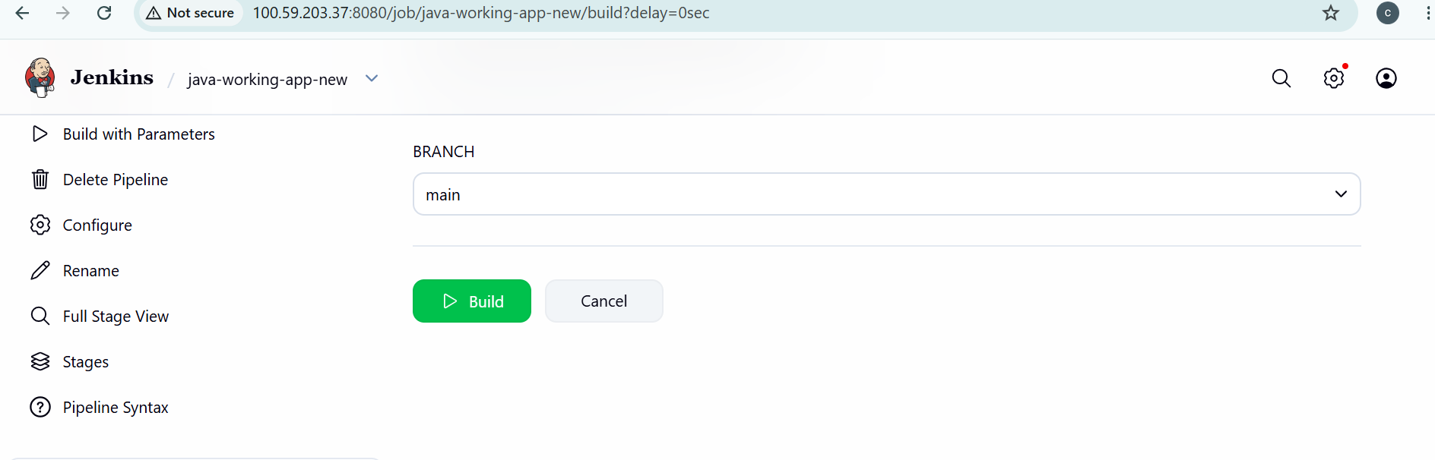

Step 5: Check Console Output
Go to:
Build #1 → Console Output
mvn clean compile
...
BUILD SUCCESS
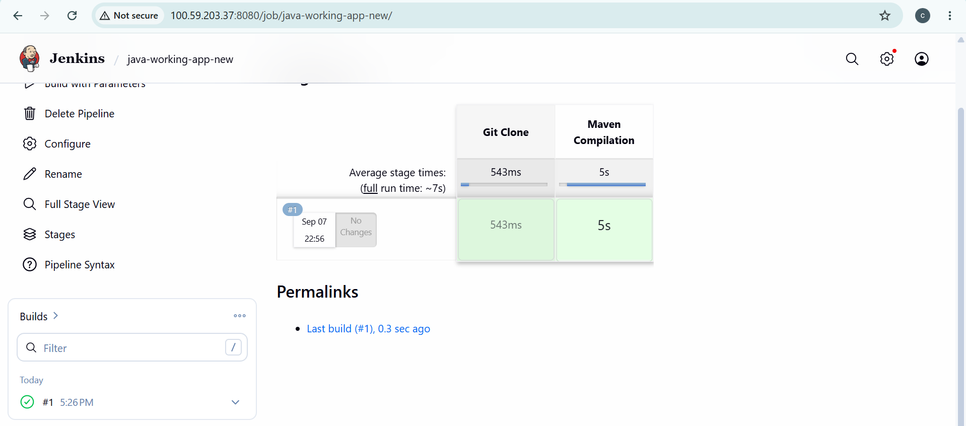

5. What are the global variables in Jenkins?.
In Jenkins, global variables are variables that are available throughout the Jenkins Pipeline.
Common Jenkins global variables
Variable | Meaning | Example
env | Environment variables | env.BUILD_NUMBER
params | Build parameters | params.BRANCH
currentBuild | Current build information | currentBuild.result
JOB_NAME | Jenkins job name | echo "${JOB_NAME}"
BUILD_NUMBER | Current build number | echo "${BUILD_NUMBER}"
BUILD_ID | Current build ID | echo "${BUILD_ID}"
BUILD_URL | URL of the build | echo "${BUILD_URL}"
WORKSPACE | Workspace directory | echo "${WORKSPACE}"
NODE_NAME | Jenkins agent/node name | echo "${NODE_NAME}"

Task: Jenkins Global Variables
We will use these 3 variables:
env.BUILD_NUMBER
env.JOB_NAME
env.WORKSPACE
Step 1 — Open your Jenkins job
Go to:
Jenkins → java-working-app01 → Configure → Pipeline
Replace your current Pipeline script with:
pipeline {
agent any

stages {

stage('Git Clone') {
steps {
git branch: 'main',
url: 'https://github.com/betawins/java-Working-app.git'
}
}

stage('Show Jenkins Variables') {
steps {
echo "Job Name : ${env.JOB_NAME}"
echo "Build Number : ${env.BUILD_NUMBER}"
echo "Workspace : ${env.WORKSPACE}"
echo "Node Name : ${env.NODE_NAME}"
}
}

stage('Maven Compilation') {
steps {
sh 'mvn clean compile'
}
}
}
}
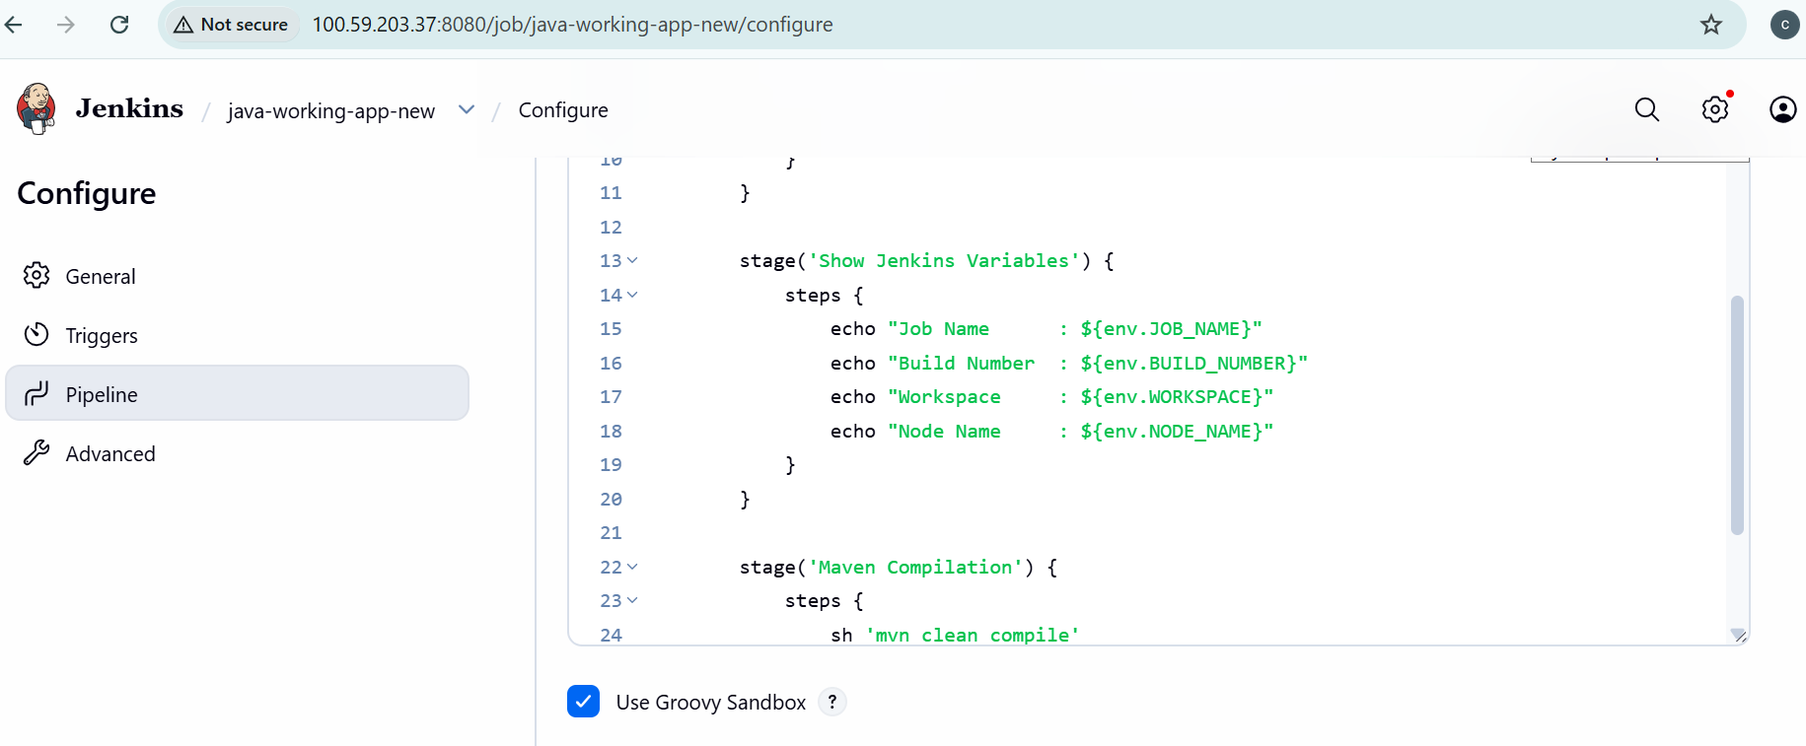
Step 2 — Save and Build
Click:
Save → Build Now
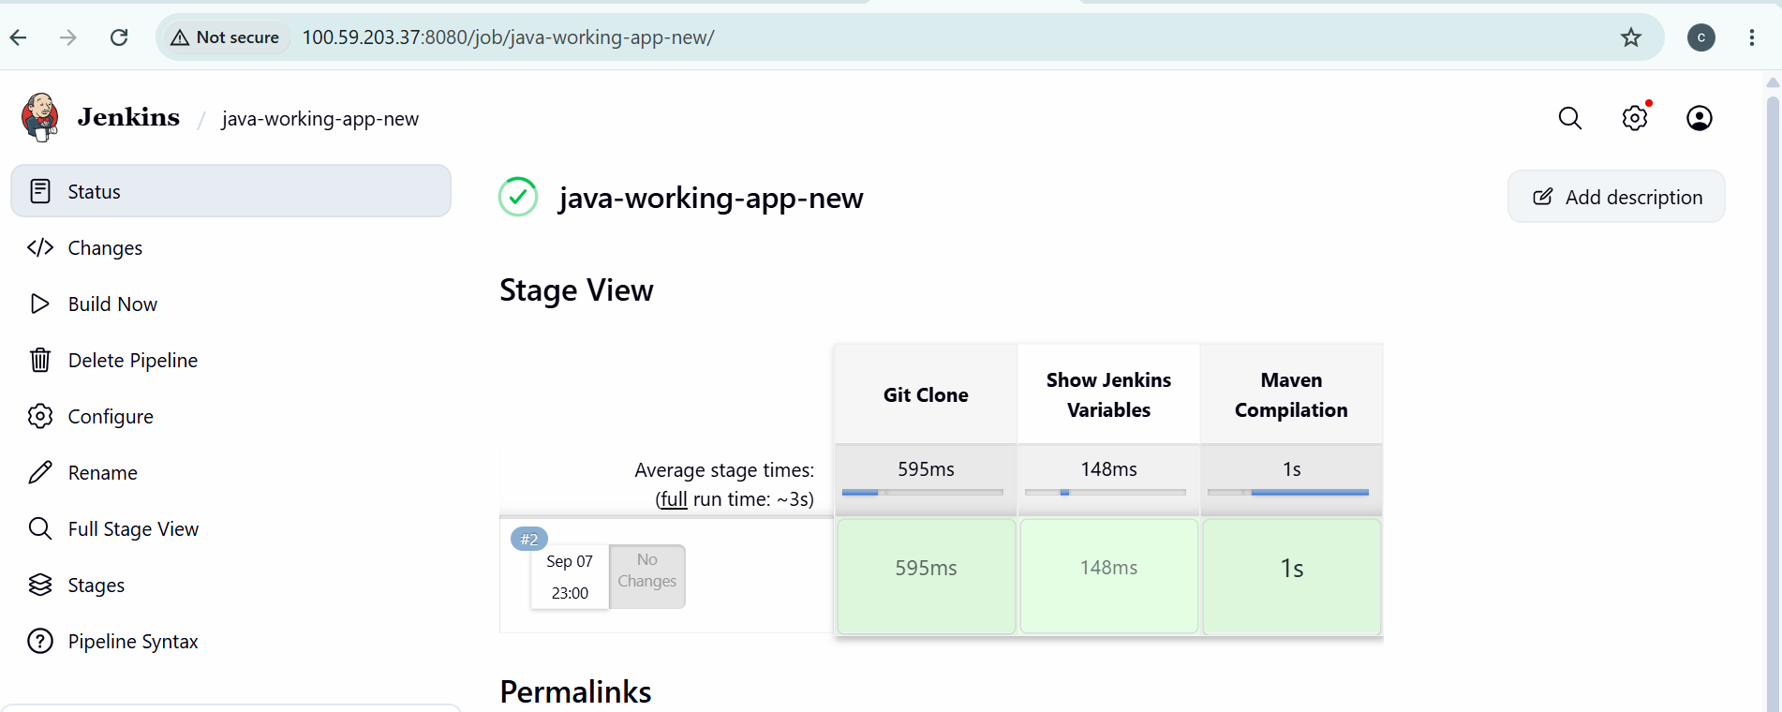
Step 3 — Check Console Output
You should see something similar to:
Job Name : java-working-app01
Build Number : 1
Workspace : /var/lib/jenkins/workspace/java-working-app01
Node Name : built-in

